**RAC System Test Plan**

**19cR3**

# Purpose

Before a new software is deployed in production it is important to test the system thoroughly to validate that it will perform at a satisfactory level, relative to its service level objectives. Testing is also required when introducing major or minor changes to the system. This system test plan can be used to thoroughly test 19c RAC implementation and their associated service level objectives.

# Scope of System Testing

This test plan will be used to validate core component functionality for RAC GI (Grid Infrastructure) configuration. Each new system must be tested thoroughly, in an environment that is a realistic representation of the production environment in terms of configuration, capacity, and workload prior to going live or after implementing significant architectural/system modifications. Without a completed system implementation and functional available end-user applications, only core component functionality and testing is possible to verify cluster, RDBMS and various sub-component behaviors for the Networking, I/O subsystem and miscellaneous database administrative functions.

In addition to the RAC GI configuration testing, this test plan also covers test cases for RMAN, backup and recovery, and Data Guard (for disaster recovery. This Test plan is limited and mainly focused on database administrative functions of 19C GI and its supported components. This test plan will not cover supported applications functionality and load testing.

**Note:** Network related Test cases are out of scope for this virtual RAC testing.

Current architecture, which consist of a VMware hypervisor for virtual deployments and a Cisco hypervisor for physical deployments, have network redundancy built-in. This built-in redundancy alleviates the need to configure NIC bonding/teaming at the OS level. As such, any test in this realm are deemed inconsequential.

# RAC Test Results Summary: TST CLUSTER

|  |  |
| --- | --- |
| **RAC** | TST |
| **SERVERS** |  |
| **TEST DATES** |  |
| **TESTERS** |  |
| **PASS/FAIL** | PASS |
| **OVERALL SUMMARY** |  |

# System Testing Scenarios : Node and Listener Failures

| **#** | **Test** | **Procedure** | **Expected Results** | **Measures** | **Actual Results/Notes** |
| --- | --- | --- | --- | --- | --- |
| 1 | **Planned Node Reboot** | Reboot one of the nodes (“Shutdown -r now”) | All services and components associated with the rebooted node should fail-over to available nodes | Successful failover of all RAC components associated with the rebooted node | Passed  Please see Appendix A (Screenshots for Node and Listener Failures) |
| 2 | **Unplanned Node**  **Failure** | Power off the node | Same as Planned Node Reboot | • Same as Planned Node Reboot | Passed  Please see Appendix A (Screenshots for Node and Listener Failures) |
| 3 | **Restart Failed Node** | Power on the node | * The VIP will migrate back to the restarted node. * Services that had failed over as a result of the node failure will   NOT automatically be relocated.   * Failed resources (asm, listener, instance, etc) will be restarted by the Clusterware. | • Time for all resources to become available again, Check with “crsctl stat res –t” | Passed  Please see Appendix A (Screenshots for Node and Listener Failures) |
| 4 | **Reboot all nodes at the same time** | • Issue a reboot on all nodes at the same time o ‘shutdown –r | * • All nodes, instances and resources are restarted without problems | • Time for all resources to become available again, Check with “crsctl stat res –t”. | Passed  Please see Appendix A (Screenshots for Node and Listener Failures) |
| 5 | **Unplanned Instance Failure** | . Kill -9 <PID of database instance> | * One of the other instances performs instance recovery * Services are moved to available instances, if a preferred instance failed * Client connections are moved / reconnected to surviving instances (Procedure and timings will depend on client types and configuration) * After a short freeze, surviving instances continue processing the workload * Failing instance will be restarted by Oracle Clusterware, unless this feature has been disabled | * Time to detect instance failure * Time to complete instance recovery. Check alert log for recovering instance • Time to restore client activity to same level (assuming remaining nodes have sufficient capacity to run workload)   Duration of database freeze during failover.   * Time before failed instance is restarted automatically by Oracle Clusterware and is accepting new connections | Passed  Please see Appendix A (Screenshots for Node and Listener Failures) |
| 6 | **Planned Instance Termination** | • Issue a ‘shutdown abort’ | * One other instance performs instance recovery * Services are moved to available instances, if a preferred instance failed * Client connections are moved / reconnected to surviving instances (Procedure and timings will depend on client types and configuration) * The instance will NOT be automatically restarted by Oracle Clusterware due to the user invoked shutdown. | * Time to detect instance failure. * Time to complete instance recovery. Check alert log for recovering instance. • Time to restore client activity to same level (assuming remaining nodes have sufficient capacity to run workload). * The instance will NOT be restarted by Oracle Clusterware due to the user induced shutdown. | Passed  Please see Appendix A (Screenshots for Node and Listener Failures) |
| 7 | **Restart Failed Instance** | * Automatic restart by Oracle Clusterware if it is an uncontrolled failure * Manual restart necessary if a “shutdown” command was issued.   Manual restart when the "Auto Start" option for the related instance has been disabled. | * Instance rejoins RAC cluster without any problems (review alert logs etc.) * Client connections and workload will be load balanced across the new instance (Manual procedure might be required to redistribute workload if long running / permanent connections) | • Time before services and workload are rebalanced across all instances (including any manual steps) | Passed  Please see Appendix A (Screenshots for Node and Listener Failures) |
| 8 | **Listener Failure** | Obtain the PID for the listener process:  # ps –ef | grep tnslsnr Kill the listener process:  # kill –9 <listener pid> • | * No impact on connected database sessions. * New connections are redirected to listener on other node * The Listener failure is detected by the ORAAGENT and is automatically restarted. Review the following logs: * $GI_HOME/log/<nodename>/ crsd/crsd.log * $GI_HOME/log/<nodename>/ agent/crsd/oraagent_<GI_own   er>/oraagent_<GI_owner>.log | * Time for the Clusterware to detect failure and restart listener. | Passed  Please see Appendix A (Screenshots for Node and Listener Failures) |
| 9 | **SCAN Listener Failure** | Obtain the PID for the SCAN listener process:  # ps –ef | grep tnslsnr Kill the listener process:  # kill –9 <listener pid> • | * No impact on connected database sessions. * New connections are redirected to listener on other node * The Listener failure is detected by CRSD ORAAGENT and is   automatically restarted. Review the following logs:   * $GI_HOME/log/<nodename>/cr sd/crsd.log * $GI_HOME/log/<nodename>/ag ent/crsd/oraagent_<GI_owner>/o raagent_<GI_owner>.log | * Same as Listener Failure | Passed  Please see Appendix A (Screenshots for Node and Listener Failures) |

# System Testing Scenarios: Clusterware Process Failures

| **#** | **Test** | **Procedure** | **Expected Results** | **Measures** | **Actual Results/Notes** |
| --- | --- | --- | --- | --- | --- |
| 1 | **CRSD Process Failure** | Obtain the PID for the CRSD process:  # ps –ef | grep crsd  Kill the CRSD process:  # kill –9 <crsd pid> | • CRSD process failure is detected by the orarootagent and CRSD is restarted. Review the following logs:  Besides ADR data, Oracle Clusterware collects or uses other data related to problem diagnosis. Starting with Oracle Clusterware 12*c* release 1 (12.1.0.2), this data resides under the same base path used by ADR, but in a separate directory structure with this form: *ORACLE_BASE*/crsdata/*host_name*. In this example, *ORACLE_BASE* is the Oracle base path you specified when you installed the Grid Infrastructure and *host_name* is the name of the host.  In this directory, on a given host, are several subdirectories. The two subdirectories of greatest interest if a problem occurs are named core and output. The core directory is where Oracle Clusterware daemon core files are written when the normal ADR location used for core files is not available (for example, before ADR services are initialized in a program). The output directory is where Oracle Clusterware daemons redirect their C standard output and standard error files. These files generally use a name structure consisting of the executable name with the characters *OUT* appended to a .trc file extension (like trace files). For example, the redirected standard output from the Cluster Time Synchronization Service daemon is named octssdOUT.trc. Typically, daemons write very little to these files, but in certain failure scenarios important data may be written there. | • Time to restart CRSD process | [root@hrvltstdb20 ~]# ps -ef | grep crsd.bin  root 15708 1 5 19:47 ? 00:00:01 /u02/app/19.3.0/grid/bin/crsd.bin reboot  root 16510 30612 0 19:48 pts/3 00:00:00 grep --color=auto crsd.bin  [root@hrvltstdb20 ~]# kill -9 15708  [root@hrvltstdb20 ~]#  Redirected Oracle Clusterware daemon standard output file /u02/app/grid/crsdata/hrvltstdb20/output/crsdOUT.trc  Initializing Oracle Clusterware CRSD daemon with OS process ID 16634 on host hrvltstdb20 at local time 2021/05/05-19:48:34.806  Oracle Home is: /u02/app/19.3.0/grid  Oracle Base is: /u02/app/grid  NLS_LANG is: AMERICAN_AMERICA.AL32UTF8  ^C  [root@hrvltstdb20 output]# pwd  /u02/app/grid/crsdata/hrvltstdb20/output  [root@hrvltstdb20 output]# tail -f crsdOUT.trc |
| 2 | **EVMD Process**  **Failure** | Obtain the PID for the EVMD process:  # ps –ef | grep evmd.bin  Kill the EVMD process:  # kill –9 <evmd pid> | • EVMD process failure is detected by the OHASD orarootagent and CRSD is restarted. Review the following logs:    Redirected Oracle Clusterware daemon standard output file /u02/app/grid/crsdata/hrvltstdb20/output/evmdOUT.trc  Initializing Oracle Clusterware EVMD daemon with OS process ID 23269 on host hrvltstdb20 at local time 2021/05/05-19:51:14.283  Oracle Home is: /u02/app/19.3.0/grid  Oracle Base is: /u02/app/grid  NLS_LANG is: AMERICAN_AMERICA.AL32UTF8 | • Time to restart the EVMD process | [root@hrvltstdb20 ~]# ps -ef | grep evmd.bin  grid 11537 1 0 11:59 ? 00:02:58 /u02/app/19.3.0/grid/bin/evmd.bin  root 22530 30612 0 19:51 pts/3 00:00:00 grep --color=auto evmd.bin  [root@hrvltstdb20 ~]# kill -9 11537  [root@hrvltstdb20 ~]# ps -ef | grep evmd.bin  grid 23269 1 9 19:51 ? 00:00:00 /u02/app/19.3.0/grid/bin/evmd.bin  root 23784 30612 0 19:51 pts/3 00:00:00 grep --color=auto evmd.bin  [root@hrvltstdb20 ~]# |
| 3 | **CSSD Process Failure** | Obtain the PID for the CSSD process:  # ps –ef | grep cssd  Kill the CSSD process:  # kill –9 <cssd pid> | * The node will reboot. * Cluster reconfiguration will take place | * Time for the eviction and cluster   reconfiguration on the surviving nodes  Time for the node to come back online and reconfiguration to complete to add the node as an active member of the cluster. | [root@hrvltstdb20 ~]# ps -ef | grep cssd  root 11991 1 0 11:59 ? 00:01:10 /u02/app/19.3.0/grid/bin/cssdmonitor  root 12326 1 0 11:59 ? 00:01:11 /u02/app/19.3.0/grid/bin/cssdagent  grid 12360 1 0 11:59 ? 00:03:51 /u02/app/19.3.0/grid/bin/ocssd.bin  root 12364 12210 0 20:06 pts/3 00:00:00 grep --color=auto cssd  [root@hrvltstdb20 ~]# kill -9 12360  [root@hrvltstdb20 ~]#  Node rebooted  [oracle@hrvltstdb20 ~]$ uptime  20:08:01 up 0 min, 1 user, load average: 1.53, 0.39, 0.13  [oracle@hrvltstdb20 ~]$  [root@hrvltstdb20 ~]# crsctl check cluster -all  **************************************************************  hrvltstdb20:  CRS-4535: Cannot communicate with Cluster Ready Services  CRS-4530: Communications failure contacting Cluster Synchronization Services daemon  CRS-4534: Cannot communicate with Event Manager  **************************************************************  [root@hrvltstdb20 ~]# crsctl check cluster -all  **************************************************************  hrvltstdb20:  CRS-4535: Cannot communicate with Cluster Ready Services  CRS-4530: Communications failure contacting Cluster Synchronization Services daemon  CRS-4534: Cannot communicate with Event Manager  **************************************************************  hrvltstdb21:  CRS-4537: Cluster Ready Services is online  CRS-4529: Cluster Synchronization Services is online  CRS-4533: Event Manager is online  **************************************************************  [root@hrvltstdb20 ~]# crsctl check cluster -all  **************************************************************  hrvltstdb20:  CRS-4535: Cannot communicate with Cluster Ready Services  CRS-4529: Cluster Synchronization Services is online  CRS-4533: Event Manager is online  **************************************************************  hrvltstdb21:  CRS-4537: Cluster Ready Services is online  CRS-4529: Cluster Synchronization Services is online  CRS-4533: Event Manager is online  **************************************************************  [root@hrvltstdb20 ~]# |
| 4 | **CRSD ORAAGENT**  **RDBMS Process**  **Failure** | Obtain the PID for the CRSD oraagent for the RDBMS software owner:  # cat  $GI_HOME/log/<nodename>/agent/crsd/oraag ent_<rdbms_owner>/oraagent_<rdbms_owner>  .pid  # kill –9 <pid for RDBMS oraagent process> | • The ORAAGENT process failure is detected by CRSD and is automatically restarted. Review the following logs:   * /u02/app/grid/crsdata/hrvltstdb20/output   /u02/app/grid/crsdata/hrvltstdb20/output/crsd_oraagent_oracleOUT.trc | • Time to restart the   * ORAAGENT process | [root@hrvltstdb20 ~]# ps -ef | grep oraagent | grep oracle  oracle 22506 1 0 May22 ? 00:14:16 /u02/app/19.3.0/grid/bin/oraagent.bin  [root@hrvltstdb20 ~]# kill -9 22506  [root@hrvltstdb20 ~]# ps -ef | grep oraagent | grep oracle  root 22159 20400 0 15:08 pts/0 00:00:00 tail -f crsd_oraagent_oracleOUT.trc  oracle 22258 1 8 15:08 ? 00:00:00 /u02/app/19.3.0/grid/bin/oraagent.bin  [root@hrvltstdb20 ~]#  [root@hrvltstdb20 output]# tail -f crsd_oraagent_oracleOUT.trc  Initializing Oracle Clusterware ORAAGENT daemon with OS process ID 22472 on host hrvltstdb20 at local time 2021/05/05-20:11:24.497  Oracle Home is: /u02/app/19.3.0/grid  Oracle Base is: /u02/app/grid  NLS_LANG is: AMERICAN_AMERICA.AL32UTF8  Agent ncpus:8 threadCount:25  Redirected Oracle Clusterware daemon standard output file /u02/app/grid/crsdata/hrvltstdb20/output/crsd_oraagent_oracleOUT.trc  Initializing Oracle Clusterware ORAAGENT daemon with OS process ID 22506 on host hrvltstdb20 at local time 2021/05/05-20:11:25.967  Oracle Home is: /u02/app/19.3.0/grid  Oracle Base is: /u02/app/grid  NLS_LANG is: AMERICAN_AMERICA.AL32UTF8  Redirected Oracle Clusterware daemon standard output file /u02/app/grid/crsdata/hrvltstdb20/output/crsd_oraagent_oracleOUT.trc  Initializing Oracle Clusterware ORAAGENT daemon with OS process ID 22258 on host hrvltstdb20 at local time 2021/05/05-15:08:51.731  Oracle Home is: /u02/app/19.3.0/grid  Oracle Base is: /u02/app/grid  NLS_LANG is: AMERICAN_AMERICA.AL32UTF8 |
| 5 | **CRSD ORAAGENT**  **Grid Infrastructure**  **Process Failure** | Obtain the PID for the CRSD oraagent for the GI software owner:  # cat  $GI_HOME/log/<nodename>/agent/crsd/oraag ent_<GI_owner>/oraagent_<GI_owner>.pid  # kill –9 <pid for GI oraagent process> | • The Grid Infrastructure ORAAGENT process failure is detected by CRSD and is automatically restarted. Review the following logs:  /u02/app/grid/crsdata/hrvltstdb20/output/crsd_oraagent_gridOUT.trc | • Time to restart the  ORAAGENT process | [root@hrvltstdb20 ~]# ps -ef | grep oraagent | grep -v oracle  grid 18294 1 0 May22 ? 00:25:31 /u02/app/19.3.0/grid/bin/oraagent.bin  grid 21737 1 1 May22 ? 01:14:46 /u02/app/19.3.0/grid/bin/oraagent.bin  root 24320 20505 0 15:11 pts/1 00:00:00 grep --color=auto oraagent  [root@hrvltstdb20 ~]# kill -9 18294 21737  [root@hrvltstdb20 ~]# ps -ef | grep oraagent | grep -v oracle  root 24539 20400 0 15:12 pts/0 00:00:00 tail -f crsd_oraagent_gridOUT.trc  grid 24553 1 9 15:12 ? 00:00:00 /u02/app/19.3.0/grid/bin/oraagent.bin  grid 24554 1 27 15:12 ? 00:00:00 /u02/app/19.3.0/grid/bin/oraagent.bin  root 24739 20505 0 15:12 pts/1 00:00:00 grep --color=auto oraagent  [root@hrvltstdb20 ~]#  [root@hrvltstdb20 output]# pwd  /u02/app/grid/crsdata/hrvltstdb20/output  [root@hrvltstdb20 output]# tail -f crsd_oraagent_gridOUT.trc  Initializing Oracle Clusterware ORAAGENT daemon with OS process ID 21393 on host hrvltstdb20 at local time 2021/05/05-20:10:45.517  Oracle Home is: /u02/app/19.3.0/grid  Oracle Base is: /u02/app/grid  NLS_LANG is: AMERICAN_AMERICA.AL32UTF8  Agent ncpus:8 threadCount:25  Redirected Oracle Clusterware daemon standard output file /u02/app/grid/crsdata/hrvltstdb20/output/crsd_oraagent_gridOUT.trc  Initializing Oracle Clusterware ORAAGENT daemon with OS process ID 21737 on host hrvltstdb20 at local time 2021/05/05-20:10:57.126  Oracle Home is: /u02/app/19.3.0/grid  Oracle Base is: /u02/app/grid  NLS_LANG is: AMERICAN_AMERICA.AL32UTF8  Redirected Oracle Clusterware daemon standard output file /u02/app/grid/crsdata/hrvltstdb20/output/crsd_oraagent_gridOUT.trc  Initializing Oracle Clusterware ORAAGENT daemon with OS process ID 24554 on host hrvltstdb20 at local time 2021/05/05-15:12:27.817  Oracle Home is: /u02/app/19.3.0/grid  Oracle Base is: /u02/app/grid  NLS_LANG is: AMERICAN_AMERICA.AL32UTF8 |
| 6 | **CRSD**  **ORAROOTAGENT**  **Process Failure** | Obtain the PID for the CRSD orarootagent:  # cat  $GI_HOME/log/<nodename>/agent/crsd/oraro otagent_root/orarootagent_root.pid”  # kill –9 <pid for orarootagent process> | • The ORAROOTAGENT process failure is detected by CRSD and is automatically restarted. Review the following logs:  /u02/app/grid/crsdata/hrvltstdb20/output/crsd_orarootagent_rootOUT.trc | • Time to restart the  ORAROOTAGENT  process | [root@hrvltstdb20 ~]# ps -ef | grep orarootagent  root 17990 1 0 May22 ? 00:23:40 /u02/app/19.3.0/grid/bin/orarootagent.bin  root 21403 1 1 May22 ? 01:22:14 /u02/app/19.3.0/grid/bin/orarootagent.bin  root 25383 20505 0 15:13 pts/1 00:00:00 grep --color=auto orarootagent  [root@hrvltstdb20 ~]# kill -9 17990 21403  [root@hrvltstdb20 ~]# ps -ef | grep orarootagent  root 25526 20400 0 15:14 pts/0 00:00:00 tail -f crsd_orarootagent_rootOUT.trc  root 26231 1 9 15:14 ? 00:00:00 /u02/app/19.3.0/grid/bin/orarootagent.bin  root 26235 1 17 15:14 ? 00:00:00 /u02/app/19.3.0/grid/bin/orarootagent.bin  root 26382 20505 0 15:14 pts/1 00:00:00 grep --color=auto orarootagent  [root@hrvltstdb20 ~]#  /u02/app/grid/crsdata/hrvltstdb20/output  [root@hrvltstdb20 output]# tail -f crsd_orarootagent_rootOUT.trc  Redirected Oracle Clusterware daemon standard output file /u02/app/grid/crsdata/hrvltstdb20/output/crsd_orarootagent_rootOUT.trc  Initializing Oracle Clusterware ORAROOTAGENT daemon with OS process ID 16739 on host hrvltstdb20 at local time 2021/05/05-19:48:37.664  Oracle Home is: /u02/app/19.3.0/grid  Oracle Base is: /u02/app/grid  NLS_LANG is: AMERICAN_AMERICA.AL32UTF8  Redirected Oracle Clusterware daemon standard output file /u02/app/grid/crsdata/hrvltstdb20/output/crsd_orarootagent_rootOUT.trc  Initializing Oracle Clusterware ORAROOTAGENT daemon with OS process ID 21403 on host hrvltstdb20 at local time 2021/05/05-20:10:45.563  Oracle Home is: /u02/app/19.3.0/grid  Oracle Base is: /u02/app/grid  NLS_LANG is: AMERICAN_AMERICA.AL32UTF8  Redirected Oracle Clusterware daemon standard output file /u02/app/grid/crsdata/hrvltstdb20/output/crsd_orarootagent_rootOUT.trc  Initializing Oracle Clusterware ORAROOTAGENT daemon with OS process ID 26231 on host hrvltstdb20 at local time 2021/05/05-15:14:32.381  Oracle Home is: /u02/app/19.3.0/grid  Oracle Base is: /u02/app/grid  NLS_LANG is: AMERICAN_AMERICA.AL32UTF8 |
| 7 | **CSSDAGENT**  **Process Failure** | Obtain the PID for the CSSDAGENT:  # ps –ef | grep cssdagent  # kill –9 <pid for cssdagent process> | • The CSSDAGENT process failure is detected by OHASD and is automatically restarted.  Review the following logs:  root@hrvltstdb20 output]# pwd  /u02/app/grid/crsdata/hrvltstdb20/output  [root@hrvltstdb20 output]# tail -f pwd  tail: cannot open âpwdâ for reading: No such file or directory  tail: no files remaining  [root@hrvltstdb20 output]# tail -f ohasd_cssdagent_rootOUT.trc | • Time to restart the CSSDAGENT process | [root@hrvltstdb20 ~]# ps -ef | grep cssdagent  root 29764 1 0 15:21 ? 00:00:00 /u02/app/19.3.0/grid/bin/cssdagent  root 32127 20505 0 15:25 pts/1 00:00:00 grep --color=auto cssdagent  [root@hrvltstdb20 ~]# kill -9 29764  [root@hrvltstdb20 ~]# ps -ef | grep cssdagent  root 32225 20400 0 15:25 pts/0 00:00:00 tail -f ohasd_cssdagent_rootOUT.trc  root 32338 1 7 15:25 ? 00:00:00 /u02/app/19.3.0/grid/bin/cssdagent  root 32360 20505 0 15:25 pts/1 00:00:00 grep --color=auto cssdagent  [root@hrvltstdb20 ~]#  [root@hrvltstdb20 output]# pwd  /u02/app/grid/crsdata/hrvltstdb20/output  [root@hrvltstdb20 output]# tail -f pwd  tail: cannot open âpwdâ for reading: No such file or directory  tail: no files remaining  [root@hrvltstdb20 output]# tail -f ohasd_cssdagent_rootOUT.trc  s0clsncssdSetPriority: scls_meta_ctx_init() success with rv = 0  s0clsncssdSetPriority: lpm initialization successful  s0clsncssdSetPriority: clsugetconf() successful  s0clsncssdSetPriority: slzgetevar() env var CLSSGC_ENVVAR_CSS_PRIORITY not set s0clsncssdSetPriority: priority value read from env is 4 and value to be set is 4  s0clsncssdSetPriority: successfully setting priority to 4  Redirected Oracle Clusterware daemon standard output file /u02/app/grid/crsdata/hrvltstdb20/output/ohasd_cssdagent_rootOUT.trc  Initializing Oracle Clusterware CSSDAGENT daemon with OS process ID 29764 on host hrvltstdb20 at local time 2021/05/05-15:21:23.855  Oracle Home is: /u02/app/19.3.0/grid  Oracle Base is: /u02/app/grid  NLS_LANG is: AMERICAN_AMERICA.AL32UTF8  main: Entered ...  s0clsncssdSetPriority: Entered  s0clsncssdSetPriority: scls_meta_init() success with rv = 0  s0clsncssdSetPriority: scls_meta_ctx_init() success with rv = 0  s0clsncssdSetPriority: lpm initialization successful  s0clsncssdSetPriority: clsugetconf() successful  s0clsncssdSetPriority: slzgetevar() env var CLSSGC_ENVVAR_CSS_PRIORITY not set s0clsncssdSetPriority: priority value read from env is 4 and value to be set is 4  s0clsncssdSetPriority: successfully setting priority to 4  Redirected Oracle Clusterware daemon standard output file /u02/app/grid/crsdata/hrvltstdb20/output/ohasd_cssdagent_rootOUT.trc  Initializing Oracle Clusterware CSSDAGENT daemon with OS process ID 32338 on host hrvltstdb20 at local time 2021/05/05-15:25:39.304  Oracle Home is: /u02/app/19.3.0/grid  Oracle Base is: /u02/app/grid  NLS_LANG is: AMERICAN_AMERICA.AL32UTF8 |
| 8 | **CSSMONITOR**  **Process Failure** | Obtain the PID for the CSSDMONITOR:  # ps –ef | grep cssdmonitor  # kill –9 <pid for cssdmonitor process> | • The CSSDMONITOR process failure is detected by OHASD and is automatically restarted.  Review the following logs:    [root@hrvltstdb20 output]# pwd  /u02/app/grid/crsdata/hrvltstdb20/output  [root@hrvltstdb20 output]# tail -f ohasd_cssdmonitor_rootOUT.trc | • Time to restart the CSSMONITOR process | [root@hrvltstdb20 ~]# ps -ef | grep cssdmonitor  root 735 20505 0 15:27 pts/1 00:00:00 grep --color=auto cssdmonitor  root 29768 1 0 15:21 ? 00:00:01 /u02/app/19.3.0/grid/bin/cssdmonitor  [root@hrvltstdb20 ~]# kill -9 29768  [root@hrvltstdb20 ~]# ps -ef | grep cssdmonitor  root 975 20400 0 15:27 pts/0 00:00:00 tail -f ohasd_cssdmonitor_rootOUT.trc  root 1075 1 11 15:27 ? 00:00:00 /u02/app/19.3.0/grid/bin/cssdmonitor  root 1104 20505 0 15:27 pts/1 00:00:00 grep --color=auto cssdmonitor  [root@hrvltstdb20 ~]#  [root@hrvltstdb20 output]# pwd  /u02/app/grid/crsdata/hrvltstdb20/output  [root@hrvltstdb20 output]# tail -f ohasd_cssdmonitor_rootOUT.trc  s0clsncssdSetPriority: scls_meta_ctx_init() success with rv = 0  s0clsncssdSetPriority: lpm initialization successful  s0clsncssdSetPriority: clsugetconf() successful  s0clsncssdSetPriority: slzgetevar() env var CLSSGC_ENVVAR_CSS_PRIORITY not set s0clsncssdSetPriority: priority value read from env is 4 and value to be set is 4  s0clsncssdSetPriority: successfully setting priority to 4  Redirected Oracle Clusterware daemon standard output file /u02/app/grid/crsdata/hrvltstdb20/output/ohasd_cssdmonitor_rootOUT.trc  Initializing Oracle Clusterware CSSDMONITOR daemon with OS process ID 29768 on host hrvltstdb20 at local time 2021/05/05-15:21:23.872  Oracle Home is: /u02/app/19.3.0/grid  Oracle Base is: /u02/app/grid  NLS_LANG is: AMERICAN_AMERICA.AL32UTF8  main: Entered ...  s0clsncssdSetPriority: Entered  s0clsncssdSetPriority: scls_meta_init() success with rv = 0  s0clsncssdSetPriority: scls_meta_ctx_init() success with rv = 0  s0clsncssdSetPriority: lpm initialization successful  s0clsncssdSetPriority: clsugetconf() successful  s0clsncssdSetPriority: slzgetevar() env var CLSSGC_ENVVAR_CSS_PRIORITY not set s0clsncssdSetPriority: priority value read from env is 4 and value to be set is 4  s0clsncssdSetPriority: successfully setting priority to 4  Redirected Oracle Clusterware daemon standard output file /u02/app/grid/crsdata/hrvltstdb20/output/ohasd_cssdmonitor_rootOUT.trc  Initializing Oracle Clusterware CSSDMONITOR daemon with OS process ID 1075 on host hrvltstdb20 at local time 2021/05/05-15:27:48.946  Oracle Home is: /u02/app/19.3.0/grid  Oracle Base is: /u02/app/grid  NLS_LANG is: AMERICAN_AMERICA.AL32UTF8 |

# Component Testing: ASM Functional Tests

| **#** | **Test** | **Procedure** | **Expected Results/Measures** | **Actual Results/Notes** |
| --- | --- | --- | --- | --- |
| 1 | **Verify that candidate disks are available.** | * Add a Disk/LUN to the RAC nodes and configure the Disk/LUN for use by ASM. * Login to ASM via SQL*Plus and run: “select name, group_number, path, state, header_status, mode_status, label from v$asm_disk” | • The newly added LUN will appear as a candidate disk within ASM. | SQL> set pages 200  SQL> l  1* select name,state,header_status,mode_status,label from v$asm_disk  SQL> /  NAME STATE HEADER_STATU MODE_ST LABEL  ------------------------------ -------- ------------ ------- -------------------------------  NORMAL PROVISIONED ONLINE ASM_DISK14  NORMAL PROVISIONED ONLINE ASM_DISK29  NORMAL PROVISIONED ONLINE ASM_DISK23  NORMAL PROVISIONED ONLINE ASM_DISK27  NORMAL PROVISIONED ONLINE ASM_DISK08  NORMAL PROVISIONED ONLINE ASM_DISK25  NORMAL PROVISIONED ONLINE ASM_DISK28  NORMAL PROVISIONED ONLINE ASM_DISK24  NORMAL PROVISIONED ONLINE ASM_DISK16  NORMAL PROVISIONED ONLINE ASM_DISK18  NORMAL PROVISIONED ONLINE ASM_DISK32  NORMAL PROVISIONED ONLINE ASM_DISK26  NORMAL PROVISIONED ONLINE ASM_DISK17  NORMAL PROVISIONED ONLINE ASM_DISK11  NORMAL PROVISIONED ONLINE ASM_DISK30  NORMAL PROVISIONED ONLINE ASM_DISK21  NORMAL PROVISIONED ONLINE ASM_DISK22  NORMAL PROVISIONED ONLINE ASM_DISK31  NORMAL PROVISIONED ONLINE ASM_DISK12  NORMAL PROVISIONED ONLINE ASM_DISK20  NORMAL PROVISIONED ONLINE ASM_DISK19  NORMAL PROVISIONED ONLINE ASM_DISK13  NORMAL PROVISIONED ONLINE ASM_DISK10  NORMAL PROVISIONED ONLINE ASM_DISK15  NORMAL PROVISIONED ONLINE ASM_DISK09  ASM_DISK04 NORMAL MEMBER ONLINE ASM_DISK04  ASM_DISK05 NORMAL MEMBER ONLINE ASM_DISK05  ASM_DISK06 NORMAL MEMBER ONLINE ASM_DISK06  ASM_DISK07 NORMAL MEMBER ONLINE ASM_DISK07  ASM_DISK01 NORMAL MEMBER ONLINE ASM_DISK01  ASM_DISK02 NORMAL MEMBER ONLINE ASM_DISK02  ASM_DISK03 NORMAL MEMBER ONLINE ASM_DISK03  32 rows selected.  SQL> |
| 2 | **Create an external redundancy ASM diskgroup using SQL*Plus** | • Login to ASM via SQL*Plus and run: “create diskgroup <dg name> external redundancy disk ‘<candidate path>’ ;“ | * A successfully created diskgroup. This diskgroup should also be listed in v$asm_diskgroup. * The diskgroup will be registered as a Clusterware resource (crsctl stat res –t) | [grid@hrvltstdb20 ~]$ asmca -silent -creatediskgroup -diskGroupName TEST -disk 'AFD:ASM_DISK20' -redundancy External  [INFO] [DBT-30001] Disk groups created successfully. Check /u02/app/grid/cfgtoollogs/asmca/asmca-210505PM034201.log for details.  [grid@hrvltstdb20 ~]$ asmcmd lsdg  State Type Rebal Sector Logical_Sector Block AU Total_MB Free_MB Req_mir_free_MB Usable_file_MB Offline_disks Voting_files Name  MOUNTED EXTERN N 512 512 4096 1048576 439908 435861 0 435861 0 N DATA/  MOUNTED EXTERN N 512 512 4096 1048576 439908 438972 0 438972 0 N FRA/  MOUNTED EXTERN N 512 512 4096 4194304 14988 14596 0 14596 0 Y OCR_VD_DG/  MOUNTED EXTERN N 512 512 4096 1048576 219851 219745 0 219745 0 N TEST/  [grid@hrvltstdb20 ~]$ asmcmd lsdg | grep TEST  MOUNTED EXTERN N 512 512 4096 1048576 219851 219745 0 219745 0 N TEST/  [grid@hrvltstdb20 ~]$  [grid@hrvltstdb20 ~]$ crsctl stat res -t | grep TEST  ora.TEST.dg(ora.asmgroup)  [grid@hrvltstdb20 ~]$ |
| 3 | **Add a disk to a ASM**  **disk group using**  **SQL*Plus** | • Login to ASM via SQL*Plus and run:  “alter diskgroup <dg name> add disk  '<candidate1 path> ;”    **NOTE:** Progress can be monitored by querying v$asm_operation | • The disk will be added to the diskgroup and the data will be rebalanced evenly across all disks in the diskgroup. | SQL> alter diskgroup test add disk 'AFD:ASM_DISK21';  Diskgroup altered.  SQL> |
| 4 | **Drop an ASM disk from a diskgroup using**  **SQL*Plus** | • Login to ASM via SQL*Plus and run:  “alter diskgroup <dg name> drop disk  <disk name>;”    **NOTE:** Progress can be monitored by querying v$asm_operation | • The data from the removed disk will be rebalanced across the remaining disks in the diskgroup. Once the rebalance is complete the disk will have a header_status of “FORMER” (v$asm_disk) and will be a candidate to be added to another diskgroup. | ASMCMD> lsdsk -G TEST  Path  AFD:ASM_DISK20  AFD:ASM_DISK21  SQL> alter diskgroup TEST drop disk 'ASM_DISK20';  Diskgroup altered.  SQL> !asmcmd  ASMCMD> lsdsk -G TEST  Path  AFD:ASM_DISK21  ASMCMD>  1* select name,path,header_status from v$asm_disk where header_status like 'F%'  SQL> /  NAME PATH HEADER_STATU  ------------------------------ ---------------------------------------- ------------  AFD:ASM_DISK20 FORMER  SQL> |
| 5 | **Undrop a ASM disk**  **that is currently being dropped using SQL*Plus** | * Login to ASM via SQL*Plus and run:   “alter diskgroup <dg name> drop disk  <disk name>;”   * Before the rebalance completes run the following command via SQL*Plus:   “alter diskgroup <dg name> undrop disk <disk name>;”    **NOTE:** Progress can be monitored by querying v$asm_operation | • The undrop operation will rollback the drop operation (assuming it has not completed). The disk entry will remain in v$asm_disk as a MEMBER. | SQL> alter diskgroup test drop disk 'ASM_DISK20';  alter diskgroup TEST undrop disks;  Diskgroup altered.  SQL> SQL>  Diskgroup altered.  ASMCMD> lsdsk -G TEST  Path  AFD:ASM_DISK20  AFD:ASM_DISK21  ASMCMD> |
| 6 | **Drop a ASM diskgroup using SQL*Plus** | • Login to ASM via SQL*Plus and run:  “drop diskgroup <dg name>;” | * The diskgroup will be successfully dropped. * The diskgroup will be unregistered as a Clusterware resource (crsctl stat res –t) | [grid@hrvltstdb21 ~]$ . oraenv  ORACLE_SID = [grid] ? +ASM2  The Oracle base has been set to /u02/app/grid  [grid@hrvltstdb21 ~]$ asmcmd lsdg  State Type Rebal Sector Logical_Sector Block AU Total_MB Free_MB Req_mir_free_MB Usable_file_MB Offline_disks Voting_files Name  MOUNTED EXTERN N 512 512 4096 1048576 439908 435861 0 435861 0 N DATA/  MOUNTED EXTERN N 512 512 4096 1048576 439908 438972 0 438972 0 N FRA/  MOUNTED EXTERN N 512 512 4096 4194304 14988 14596 0 14596 0 Y OCR_VD_DG/  MOUNTED EXTERN N 512 512 4096 1048576 329827 329718 0 329718 0 N TEST/  [grid@hrvltstdb21 ~]$ asmcmd umount test  [grid@hrvltstdb21 ~]$ exit  logout  Connection to hrvltstdb21 closed.  [grid@hrvltstdb20 ~]$ sqlplus / as sysasm  SQL*Plus: Release 19.0.0.0.0 - Production on Wed May 05 16:00:23 2021  Version 19.10.0.0.0  Copyright (c) 1982, 2019, Oracle. All rights reserved.  Connected to:  Oracle Database 19c Enterprise Edition Release 19.0.0.0.0 - Production  Version 19.10.0.0.0  SQL> drop diskgroup test including contents;  Diskgroup dropped.  SQL> |
| 7 | **Verify CSS-database communication and ASM files access.** | • Start all the database instances and query the v$asm_client view in the ASM instances. | • Each database instance should be listed in the v$asm_client view. | SQL> select db_name from v$asm_client;  DB_NAME  --------  +ASM  _OCR  SAMPLEDB  SAMPLEDB  SQL> |
| 8 | **Check the internal consistency of disk group metadata using SQL*Plus** | • Login to ASM via SQL*Plus and run:  “alter diskgroup <name> check all” | • If there are no internal inconsistencies, the statement “Diskgroup altered” will be returned (asmcmd will return back to the asmcmd prompt). If inconsistencies are discovered, then appropriate messages are displayed describing the problem. | SQL> alter diskgroup data check all;  Diskgroup altered.  SQL> |

# Component Testing: ASM Functional Tests –ASMCMD

| **#** | **Test** | **Procedure** | **Expected Results/Measures** | **Actual Results/Notes** |
| --- | --- | --- | --- | --- |
| 1 | **Verify that candidate disks are available.** | * Add a Disk/LUN to the RAC nodes and configure the Disk/LUN for use by ASM. * Login to ASM via ASMCMD and run:   “lsdsk --candidate | • The newly added LUN will appear as a candidate disk within ASM. | [grid@hrvltstdb20 ~]$ asmcmd  ASMCMD> lsdsk --candidate  Path  AFD:ASM_DISK08  AFD:ASM_DISK09  AFD:ASM_DISK10  AFD:ASM_DISK11  AFD:ASM_DISK12  AFD:ASM_DISK13  AFD:ASM_DISK14  AFD:ASM_DISK15  AFD:ASM_DISK16  AFD:ASM_DISK17  AFD:ASM_DISK18  AFD:ASM_DISK19  AFD:ASM_DISK20  AFD:ASM_DISK21  AFD:ASM_DISK22  AFD:ASM_DISK23  AFD:ASM_DISK24  AFD:ASM_DISK25  AFD:ASM_DISK26  AFD:ASM_DISK27  AFD:ASM_DISK28  AFD:ASM_DISK29  AFD:ASM_DISK30  AFD:ASM_DISK31  AFD:ASM_DISK32  ASMCMD> |
| 2 | **Create an external redundancy ASM**  **diskgroup using**  **ASMCMD** | * Identify the candidate disks for the diskgroup by running:   “lsdsk –candidate”     * Create a XML config file to define the diskgroup e.g.   <dg name="<dg name>" redundancy="external">  <dsk string="<disk path>" />  <a name="compatible.asm" value="11.1"/>  <a name="compatible.rdbms" value="11.1"/>  </dg>   * Login to ASM via ASMCMD and run:   “mkdg <config file>.xml” | * A successfully created diskgroup. This diskgroup can be viewed using the “lsdg” ASMCMD command. * The diskgroup will be registered as a Clusterware resource (crsctl stat res –t) | [grid@hrvltstdb20 ~]$ asmcmd  ASMCMD> lsdsk --candidate  Path  AFD:ASM_DISK08  AFD:ASM_DISK09  AFD:ASM_DISK10  AFD:ASM_DISK11  AFD:ASM_DISK12  AFD:ASM_DISK13  AFD:ASM_DISK14  AFD:ASM_DISK15  AFD:ASM_DISK16  AFD:ASM_DISK17  AFD:ASM_DISK18  AFD:ASM_DISK19  AFD:ASM_DISK20  AFD:ASM_DISK21  AFD:ASM_DISK22  AFD:ASM_DISK23  AFD:ASM_DISK24  AFD:ASM_DISK25  AFD:ASM_DISK26  AFD:ASM_DISK27  AFD:ASM_DISK28  AFD:ASM_DISK29  AFD:ASM_DISK30  AFD:ASM_DISK31  AFD:ASM_DISK32  ASMCMD>  [grid@hrvltstdb20 ~]$ cat dg.xml  <dg name="TESTDG" redundancy="external">  <dsk string="AFD:ASM_DISK17" />  <a name="compatible.asm" value="19.3"/>  <a name="compatible.rdbms" value="19.3"/>  </dg>  [grid@hrvltstdb20 ~]$ asmcmd mkdg dg.xml  [grid@hrvltstdb20 ~]$ crsctl stat res -t | grep TESTDG  ora.TESTDG.dg(ora.asmgroup)  [grid@hrvltstdb20 ~]$ |
| 3 | **Add a disk to a ASM**  **disk group using**  **ASMCMD** | * Identify the candidate disk to be added by running: “lsdsk –candidate” * Create a XML config file to define the diskgroup change e.g.   <chdg name="<dg name>">  <add>  <dsk string="<disk path>"/>  </add>  </chdg>   * Login to ASM via ASMCMD and run:   “chdg <config file>.xml”    **NOTE:** Progress can be monitored by  running “lsop” | • The disk will be added to the diskgroup and the data will be rebalanced evenly across all disks in the diskgroup. Progress of the rebalance can be monitored by running the “lsop” ASMCMD command. | [grid@hrvltstdb20 ~]$ cat chdg.xml  <chdg name="TESTDG">  <add>  <dsk string="AFD:ASM_DISK19" />  </add>  </chdg>  [grid@hrvltstdb20 ~]$ asmcmd chdg chdg.xml  Diskgroup altered.  [grid@hrvltstdb20 ~]$ asmcmd lsop  Group_Name Pass State Power EST_WORK EST_RATE EST_TIME  [grid@hrvltstdb20 ~]$ asmcmd lsdsk -G TESTDG  Path  AFD:ASM_DISK17  AFD:ASM_DISK19  [grid@hrvltstdb20 ~]$ |
| 4 | **Drop an ASM disk from a diskgroup using ASMCMD** | * Identify the ASM name for the disk to be dropped from the given diskgroup:   “lsdsk -G <dg name> -k   * Create a XML config file to define the diskgroup change e.g.   <chdg name="<dg name>">  <drop>  <dsk name="<disk name>"/>  </drop>  </chdg>   * Login to ASM via ASMCMD and run:   “chdg <config file>.xml”    **NOTE:** Progress can be monitored by  running “lsop” | * The data from the removed disk will be rebalanced across the remaining disks in the diskgroup. Once the rebalance is complete the disk will be listed as a candidate (lsdsk – candidate) to be added to another diskgroup. Progress can be monitored by running “lsop”   The diskgroup will be unregistered as a Clusterware resource (crsctl stat res –t) | [grid@hrvltstdb20 ~]$ asmcmd lsdsk -G TESTDG  Path  AFD:ASM_DISK17  AFD:ASM_DISK19  [grid@hrvltstdb20 ~]$ cat chdg.xml  <chdg name="TESTDG">  <drop>  <dsk name="ASM_DISK19" />  </drop>  </chdg>  [grid@hrvltstdb20 ~]$ asmcmd chdg chdg.xml  Diskgroup altered.  [grid@hrvltstdb20 ~]$ asmcmd lsdsk -G TESTDG  Path  AFD:ASM_DISK17  [grid@hrvltstdb20 ~]$ asmcmd lsop  Group_Name Pass State Power EST_WORK EST_RATE EST_TIME  [grid@hrvltstdb20 ~]$ |
| 5 | **Modify rebalance power of an active**  **operation using**  **ASMCMD** | * Add a disk to a diskgroup (as shown above). * Identify the rebalance operation by running “lsop” via ASMCMD. * Before the rebalance completes run the following command via ASMCMD:   “rebal –power <1-11> <dg name>.    **NOTE:** Progress can be monitored by   * running “lsop” | • The rebalance power of the current operation will be increased to the specified value. This is visible with the lsop command. | [grid@hrvltstdb20 ~]$ asmcmd rebal --power 5 TESTDG  Rebal on progress.  [grid@hrvltstdb20 ~]$ asmcmd lsop  Group_Name Pass State Power EST_WORK EST_RATE EST_TIME  [grid@hrvltstdb20 ~]$ |
| 6 | **Drop a ASM diskgroup using**  **ASMCMD** | • Login to ASM via ASMCMD and run:  “dropdg <dg name>;” | * The diskgroup will be successfully dropped.   The diskgroup will be unregistered as a Clusterware resource (crsctl stat res –t) | [grid@hrvltstdb20 ~]$ asmcmd lsdg  State Type Rebal Sector Logical_Sector Block AU Total_MB Free_MB Req_mir_free_MB Usable_file_MB Offline_disks Voting_files Name  MOUNTED EXTERN N 512 512 4096 1048576 439908 435851 0 435851 0 N DATA/  MOUNTED EXTERN N 512 512 4096 1048576 439908 438972 0 438972 0 N FRA/  MOUNTED EXTERN N 512 512 4096 4194304 14988 14596 0 14596 0 Y OCR_VD_DG/  MOUNTED EXTERN N 512 512 4096 1048576 219851 219789 0 219789 0 N TESTDG/  [grid@hrvltstdb20 ~]$ crsctl stat res -t | grep dg  ora.DATA.dg(ora.asmgroup)  ora.FRA.dg(ora.asmgroup)  ora.OCR_VD_DG.dg(ora.asmgroup)  ora.TESTDG.dg(ora.asmgroup)  [grid@hrvltstdb20 ~]$ asmcmd dropdg TESTDG  [grid@hrvltstdb20 ~]$ asmcmd lsdg  State Type Rebal Sector Logical_Sector Block AU Total_MB Free_MB Req_mir_free_MB Usable_file_MB Offline_disks Voting_files Name  MOUNTED EXTERN N 512 512 4096 1048576 439908 435851 0 435851 0 N DATA/  MOUNTED EXTERN N 512 512 4096 1048576 439908 438972 0 438972 0 N FRA/  MOUNTED EXTERN N 512 512 4096 4194304 14988 14596 0 14596 0 Y OCR_VD_DG/  [grid@hrvltstdb20 ~]$ crsctl stat res -t | grep dg  ora.DATA.dg(ora.asmgroup)  ora.FRA.dg(ora.asmgroup)  ora.OCR_VD_DG.dg(ora.asmgroup)  [grid@hrvltstdb20 ~]$ |

# Component Testing: ASM Objects Functional Tests

| **#** | **Test** | **Procedure** | **Expected Results/Measures** | **Actual Results/Notes** |
| --- | --- | --- | --- | --- |
| 1 | **Create an ASM template** | • Login to ASM via SQL*Plus and run: “alter diskgroup <dg name> add template unreliable  attributes(unprotected fine);” | • The ASM template will be successfully created and visible within the c view. | [grid@hrvltstdb20 ~]$ asmca -createDiskGroup -diskGroupName TESTDG -disk 'AFD:ASM_DISK15' -redundancy EXTERNAL -silent  [INFO] [DBT-30001] Disk groups created successfully. Check /u02/app/grid/cfgtoollogs/asmca/asmca-210427AM105302.log for details.  [grid@hrvltstdb20 ~]$ crsctl stat res -t | grep TESTDG  ora.TESTDG.dg(ora.asmgroup)  [grid@hrvltstdb20 ~]$ sqlplus / as sysasm  SQL*Plus: Release 19.0.0.0.0 - Production on Tue May 05 10:54:00 2021  Version 19.10.0.0.0  Copyright (c) 1982, 2019, Oracle. All rights reserved.  Connected to:  Oracle Database 19c Enterprise Edition Release 19.0.0.0.0 - Production  Version 19.10.0.0.0  SQL> ALTER DISKGROUP TESTDG ADD TEMPLATE my_template ATTRIBUTES (UNPROTECTED FINE);  Diskgroup altered.  SQL> select * from v$asm_template where name='MY_TEMPLATE';  GROUP_NUMBER ENTRY_NUMBER REDUND STRIPE S NAME PRIM  ------------ ------------ ------ ------ - ------------------------------ ----  MIRR CON_ID  ---- ----------  4 446 UNPROT FINE N MY_TEMPLATE COLD  COLD 0  SQL> |
| 2 | **Apply an ASM template** | * Use the template above and apply it to a new tablespace to be created on the database * Login to ASM via SQL*Plus and run: “create tablespace test datafile '+<dg   name>/my_files(unreliable)' size  10M;” | • The datafile is created using the attributes of the ASM template | SQL> create tablespace test datafile '+TESTDG' size 10M;  Tablespace created.  SQL> |
| 3 | **Drop an ASM template** | • Login to ASM via SQL*Plus and run: “alter diskgroup <dg name> drop  template unreliable;” | • This template should be removed from v$asm_template. | SQL> alter diskgroup testdg drop template my_template;  Diskgroup altered.  SQL> select * from v$asm_template where name='MY_TEMPLATE';  no rows selected  SQL> |
| 4 | **Create an ASM directory** | • Login to ASM via SQL*Plus and run: “alter diskgroup <dg name> add directory '+<dg name>/my_files';” | * You can use the asmcmd tool to check that the new directory name was created in the desired diskgroup.      * The created directory will have an entry in v$asm_directory | SQL> alter diskgroup testdg add directory '+TESTDG/testdirectory';  Diskgroup altered.  Exit  SQL> !asmcmd ls +TESTDG  SAMPLEDB/  testdirectory/  SQL> |
| 5 | **Create an ASM alias** | • Login to ASM via SQL*Plus and run:  “alter diskgroup DATA add alias  '+DATA/my_files/datafile_alias' for  '+<dg name>/  <db name>/DATAFILE/<file name>';” | • Verify that the alias exists in v$asm_alias | SQL> alter diskgroup data add alias '+DATA/spfile.ora' for '+data/sampledb/parameterfile/spfile.268.1070547143';  Diskgroup altered.  SQL> select * from v$asm_alias where name = 'spfile.ora';  NAME  ----------------------------------------------------------------------  GROUP_NUMBER FILE_NUMBER FILE_INCARNATION ALIAS_INDEX ALIAS_INCARNATION  ------------ ----------- ---------------- ----------- -----------------  PARENT_INDEX REFERENCE_INDEX A S CON_ID  ------------ --------------- - - ----------  spfile.ora  2 268 1070547143 1 3  33554432 50331647 N N 0  SQL> |
| 6 | **Drop an ASM alias** | • Login to ASM via SQL*Plus and run:  “alter diskgroup DATA drop alias  '+<dg name>/my_files/ datafile_alias';” | • Verify that the alias does not exist in v$asm_alias. | SQL> alter diskgroup data drop alias '+DATA/spfile.ora';  Diskgroup altered.  SQL> select * from v$asm_alias where name = 'spfile.ora';  no rows selected  SQL> |
| 7 | **Drop an active database file within ASM** | * Identify a data file from a running database. * Login to ASM via SQL*Plus and run:   “alter diskgroup data drop file '+<dg name>/<db name>/DATAFILE/<file name>';” | • This will fail with the following message: ERROR at line 1:  ORA-15032: not all alterations performed  ORA-15028: ASM file  '+DATA/V102/DATAFILE/TEST.269.654602409' not dropped; currently being accessed | SQL> select name from v$datafile;  NAME  --------------------------------------------------------------------------------  +DATA/SAMPLEDB/DATAFILE/system.257.1070546509  +TESTDG/SAMPLEDB/DATAFILE/test.256.1070967395  +DATA/SAMPLEDB/DATAFILE/sysaux.258.1070546545  +DATA/SAMPLEDB/DATAFILE/undotbs1.259.1070546569  +DATA/SAMPLEDB/DATAFILE/undotbs2.265.1070547107  +DATA/SAMPLEDB/DATAFILE/users.260.1070546571  6 rows selected.  SQL> exit  Disconnected from Oracle Database 19c Enterprise Edition Release 19.0.0.0.0 - Production  Version 19.10.0.0.0  [oracle@hrvltstdb20 ~]$ sudo su - grid  Last login: Tue May 05 10:57:59 EDT 2021 on pts/0  Last login: Tue May 05 11:22:02 EDT 2021 on pts/0  [grid@hrvltstdb20 ~]$ . oraenv  ORACLE_SID = [grid] ? +ASM1  The Oracle base has been set to /u02/app/grid  [grid@hrvltstdb20 ~]$ asmcmd rm +DATA/SAMPLEDB/DATAFILE/system.257.1070546509  ORA-15032: not all alterations performed  ORA-15028: ASM file '+DATA/SAMPLEDB/DATAFILE/system.257.1070546509' not dropped; currently being accessed (DBD ERROR: OCIStmtExecute)  [grid@hrvltstdb20 ~]$ |
| 8 | **Drop an inactive**  **database file within**  **ASM** | * Identify a datafile that is no longer used by a database * Login to ASM via SQL*Plus and run:   “alter diskgroup data drop file '+<dg name>/<db name>/DATAFILE/<file name>';” | • Observe that file number in v$asm_file is now removed. | [grid@hrvltstdb20 ~]$ asmcmd cp +DATA/SAMPLEDB/DATAFILE/users.260.1070546571 +DATA/SAMPLEDB/DATAFILE/notused  copying +DATA/SAMPLEDB/DATAFILE/users.260.1070546571 -> +DATA/SAMPLEDB/DATAFILE/notused  [grid@hrvltstdb20 ~]$ asmcmd rm +DATA/SAMPLEDB/DATAFILE/notused  [grid@hrvltstdb20 ~]$ |

# 

# Component Testing: ASM ACFS Functional Tests

| **#** | **Test** | **Procedure** | **Expected Results/Measures** | **Actual Results/Notes** |
| --- | --- | --- | --- | --- |
| 1 | **Create an ASM Dynamic Volume** | * Create an ASM diskgroup to house the ASM Logical Volume.   ASMCMD or SQL*Plus may be used  to achieve this task. The diskgroup compatibility attributes  COMPATIBLE.ASM and  COMPATIBLE.ADVM must be set to 11.2 or higher.   * Login to ASM via ASMCMD and   create the logical volume to house the ACFS filesystem:  “volcreate –G <dg name> -s <size>  <vol name>” | • The volume will be created with the specified attributes. The volume can be viewed in ASMCMD by running “volinfo –a”. | [grid@hrvltstdb20 ~]$ asmca -createDiskGroup -diskGroupName ACFSDG -disk 'AFD:ASM_DISK19' -redundancy EXTERNAL -silent  [INFO] [DBT-30001] Disk groups created successfully. Check /u02/app/grid/cfgtoollogs/asmca/asmca-210427PM025117.log for details.  [grid@hrvltstdb20 ~]$  [grid@hrvltstdb20 ~]$ asmcmd volcreate -G ACFSDG -s 50G ACFSVOL  [grid@hrvltstdb20 ~]$ asmcmd -p  ASMCMD [+] > volinfo --all  Diskgroup Name: ACFSDG  Volume Name: ACFSVOL  Volume Device: /dev/asm/acfsvol-325  State: ENABLED  Size (MB): 51200  Resize Unit (MB): 64  Redundancy: UNPROT  Stripe Columns: 8  Stripe Width (K): 1024  Usage:  Mountpath:  ASMCMD [+] > |
| 2 | **Create an ACFS filesystem** | * Within ASMCMD issue the “volinfo –a” command and take note of the Volume Device path. * As the root user create an ACFS filesystem on the ASM Volume as follows: * “/sbin/mkfs –t acfs <volume device path>” | • The filesystem will be successfully created. The filesystem attributes can be viewed by running “/sbin/acfsutil info fs” | ASMCMD [+] > volinfo --all  Diskgroup Name: ACFSDG  Volume Name: ACFSVOL  Volume Device: /dev/asm/acfsvol-325  State: ENABLED  Size (MB): 51200  Resize Unit (MB): 64  Redundancy: UNPROT  Stripe Columns: 8  Stripe Width (K): 1024  Usage:  Mountpath:  ASMCMD [+] > |
| 3 | **Mount the ACFS filesystem** | • As the root user execute the following to mount the ACFS filesystem:  “/sbin/mount –t acfs <volume device path> <mount point>     * **NOTE:** If acfsutil was not used to register the file system, the dynamic volume must be enabled on the remote nodes before mounting (within ASMCMD run volenable). | • The filesystem will successfully be mounted and will be visible. | [root@hrvltstdb20 ~]# mkdir /acfsshare  [root@hrvltstdb20 ~]# chown oracle:oinstall /acfsshare  [grid@hrvltstdb20 ~]$ ssh hrvltstdb21  [grid@hrvltstdb21 ~]$ sudo su -  [root@hrvltstdb21 ~]# mkdir /acfsshare  [root@hrvltstdb21 ~]#  [root@hrvltstdb21 ~]# chown oracle:oinstall /acfsshare    [root@hrvltstdb20 ~]# /sbin/mkfs -t acfs /dev/asm/acfsvol-325  mkfs.acfs: version = 19.0.0.0.0  mkfs.acfs: on-disk version = 46.0  mkfs.acfs: volume = /dev/asm/acfsvol-325  mkfs.acfs: volume size = 53687091200 ( 50.00 GB )  mkfs.acfs: Format complete.  [root@hrvltstdb20 ~]#  [root@hrvltstdb20 grid]# /u02/app/19.3.0/grid/bin/srvctl add filesystem -d /dev/asm/acfsvol-325 -m /acfsshare -u oracle -fstype ACFS -autostart ALWAYS  [root@hrvltstdb20 grid]#  srvctl start filesystem -d /dev/asm/acfsvol-325  [root@hrvltstdb20 grid]# /infshare/oracle/scripts/dba/rac-status.sh -all  Cluster TST2-EW  Type | Name | db25 | db26 |  -------------------------------------------------------------------  acfs | acfsdg.acfsvol | Online | Online | mounted on /acfsshare  advm | ACFSDG.ACFSVOL | Online | Online | |
| 4 | **Add an ACFS filesystem to the ACFS mount**  **registry** | • Use acfsutil to register the ACFS filesystem:  “/sbin/acfsutil registry –a <volume device path> <mount point> | * The filesystem will be registered with the ACFS registry. This can be validated by running   “/sbin/acfsutil registry –l”  The filesystem will be automounted on all nodes in the cluster on reboot | [root@hrvltstdb20 ~]# mkdir /acfsshare  [root@hrvltstdb20 ~]# chown oracle:oinstall /acfsshare  [grid@hrvltstdb20 ~]$ ssh hrvltstdb21  [grid@hrvltstdb21 ~]$ sudo su -  [root@hrvltstdb21 ~]# mkdir /acfsshare  [root@hrvltstdb21 ~]#  [root@hr  vltstdb21 ~]# chown oracle:oinstall /acfsshare    [root@hrvltstdb20 ~]# /sbin/mkfs -t acfs /dev/asm/acfsvol-325  mkfs.acfs: version = 19.0.0.0.0  mkfs.acfs: on-disk version = 46.0  mkfs.acfs: volume = /dev/asm/acfsvol-325  mkfs.acfs: volume size = 53687091200 ( 50.00 GB )  mkfs.acfs: Format complete.  [root@hrvltstdb20 ~]#  [root@hrvltstdb20 grid]# /u02/app/19.3.0/grid/bin/srvctl add filesystem -d /dev/asm/acfsvol-325 -m /acfsshare -u oracle -fstype ACFS -autostart ALWAYS  [root@hrvltstdb20 grid]#  srvctl start filesystem -d /dev/asm/acfsvol-325  [root@hrvltstdb20 grid]# /infshare/oracle/scripts/dba/rac-status.sh -all  Cluster TST2-EW  Type | Name | db25 | db26 |  -------------------------------------------------------------------  acfs | acfsdg.acfsvol | Online | Online | mounted on /acfsshare  advm | ACFSDG.ACFSVOL | Online | Online  [root@hrvltstdb20 ~]# /sbin/acfsutil registry -a /dev/asm/acfsvol-325 /acfsshare  acfsutil registry: ACFS-03161: Device : /dev/asm/acfsvol-325 : Mount Point : /acfsshare already exists in the Oracle Registry  [root@hrvltstdb20 ~]# /sbin/acfsutil registry -l /dev/asm/acfsvol-325 /acfsshare  Device : /dev/asm/acfsvol-325 : Mount Point : /acfsshare : Options : none : Nodes : all : Disk Group: ACFSDG : Primary Volume : ACFSVOL : Accelerator Volumes :  Device : /dev/asm/acfsvol-325 : Mount Point : /acfsshare : Options : none : Nodes : all : Disk Group: ACFSDG : Primary Volume : ACFSVOL : Accelerator Volumes :  [root@hrvltstdb20 ~]# |
| 5 | **Create a file on the ACFS filesystem** | * Perform the following:   “echo “Testing ACFS” > <mount point>/testfile   * Perform a “cat” command on the file on all nodes in the cluster. | • The file will exist on all nodes with the specified contents. | [root@hrvltstdb20 ~]# echo "Testing" > /acfsshare/acfstest.txt  [root@hrvltstdb20 ~]# ls -altrh /acfsshare/  total 104K  dr-xr-xr-x. 23 root root 4.0K May 05 14:56 ..  drwx------. 2 root root 64K May 05 15:06 lost+found  drwxr-xr-x. 4 oracle oinstall 32K May 05 15:11 .  -rw-r--r--. 1 root root 8 May 05 15:11 acfstest.txt  [oracle@hrvltstdb20 ~]$ ssh hrvltstdb21 ls -altrh /acfsshare  total 104K  dr-xr-xr-x. 23 root root 4.0K May 05 14:57 ..  drwx------. 2 root root 64K May 05 15:06 lost+found  drwxr-xr-x. 4 oracle oinstall 32K May 05 15:06 .  -rw-r--r--. 1 root root 8 May 05 15:11 acfstest.txt  [oracle@hrvltstdb20 ~]$ |
| 6 | **Remove an ACFS**  **filesystem from the ACFS mount registry** | • Use acfsutil to register the ACFS filesystem:  “/sbin/acfsutil registry –d <volume device path> | * The filesystem will be unregistered with the ACFS registry. This can be validated by running   “/sbin/acfsutil registry –l”  The filesystem will NOT be automounted on all nodes in the cluster on reboot | [root@hrvltstdb20 ~]# /sbin/acfsutil registry -d /dev/asm/acfsvol-325  acfsutil registry: successfully removed ACFS volume /dev/asm/acfsvol-325 from Oracle Registry  [root@hrvltstdb20 ~]# /sbin/acfsutil registry -l /dev/asm/acfsvol-325 /acfsshare  acfsutil registry: ACFS-03136: unable to locate volume /dev/asm/acfsvol-325 in Cluster Ready Services  [root@hrvltstdb20 ~]#  [root@hrvltstdb20 ~]# /sbin/acfsutil registry -a /dev/asm/acfsvol-325 /acfsshare  acfsutil registry: mount point /acfsshare successfully added to Oracle Registry  [root@hrvltstdb20 ~]# /infshare/oracle/scripts/dba/rac-status.sh -all  Cluster TST2-EW  Type | Name | db25 | db26 |  -------------------------------------------------------------------  acfs | acfsdg.acfsvol | Online | Online | mounted on /acfsshare |
| 7 | **Add an ACFS filesystem as a Clusterware resource**    **NOTE:** This is required when using ACFS for a shared RDBMS Home. When ACFS is registered as a CRS resource it should NOT be registered in the ACFS mount registry. | * Execute the following command as root to add a ACFS filesystem as a Clusterware resource:   “svrctl add filesystem –d < volume device path> -v <volume name> -g <dg name> -m <mount point> -u root”   * Start the ACFS filesystem resource:   “svrctl start filesystem –d <volume device path>” | * The filesystem will be registered as a resource within the Clusterware. This can be validated by running “crsctl stat res –t” * The filesystem will be automounted on all nodes in the cluster on reboot | [root@hrvltstdb20 grid]# /u02/app/19.3.0/grid/bin/srvctl add filesystem -d /dev/asm/acfsvol-325 -m /acfsshare -u oracle -fstype ACFS -autostart ALWAYS  [root@hrvltstdb20 grid]#  srvctl start filesystem -d /dev/asm/acfsvol-325  [root@hrvltstdb20 grid]# /infshare/oracle/scripts/dba/rac-status.sh -all  Cluster TST2-EW  Type | Name | db25 | db26 |  -------------------------------------------------------------------  acfs | acfsdg.acfsvol | Online | Online | mounted on /acfsshare  advm | ACFSDG.ACFSVOL | Online | Online | |
| 8 | **Increase the size of a ACFS filesystem** | * Add a disk to the diskgroup housing the ACFS filesystem (if necessary) * Use acfsutil as the root user to resize the ACFS filesystem:   “acfsutil size <size><K|M|G> <mount point>” | • The dynamic volume and filesystem will be resized without an outage of the filesystem provided enough free space exists in the diskgroup. Validate with “df – h”. | [root@hrvltstdb20 ~]# df -h | grep acfs  /dev/asm/acfsvol-325 50G 715M 50G 2% /acfsshare  [root@hrvltstdb20 ~]# acfsutil size 60G /acfsshare/  acfsutil size: new file system size: 64424509440 (61440MB)  [root@hrvltstdb20 ~]# df -h | grep acfs  /dev/asm/acfsvol-325 60G 735M 60G 2% /acfsshare  [root@hrvltstdb20 ~]# |
| 10 | **Create a snapshot of a ACFS filesystem** | • Use acfsutil to create a snapshot of an ACFS filesystem:  “/sbin/acfsutil snap create <name> <ACFS mount point>” | • A snapshot of the ACFS file system will be created under <ACFS mount point>/.ACFS/snaps. | FAILED  [root@hrvltstdb20 ~]# /sbin/acfsutil snap create acfssnap /acfsshare  acfsutil snap create: Snapshot operation is complete.  [root@hrvltstdb20 ~]#  SNAPS are not getting created under /.ACFS/snaps |
| 11 | **Delete a snapshot of a ACFS filesystem** | • Use acfsutil to delete a previously created snapshot of an ACFS filesystem:  “/sbin/acfsutil snap delete <name>  <ACFS mount point>” | • The specified snapshot will be deleted and will no longer appear under <ACFS mount point>/.ACFS/snaps. | FAILED |
| 12 | **Perform a FSCK of a ACFS filesystem** | • Dismount the ACFS filesystem to be checked on ALL nodes:   * If the filesystem is registered as a Clusterware resource issue “srvctl stop filesystem –d <device path>” to dismount the filesystem on all nodes * If the filesystem is only in the ACFS mount registry or is not registered with Clusterware in any way dismount the filesystem using “umount <mount point>”.   • Execute fsck on the ACFS filesystem as follows:  “sbin/fsck -a -v -y -t acfs <device path>”  This command will automatically fix any errors (-a), answer yes to any prompts (-y) and provide verbose output (-v). | • FSCK will check the specified ACFS filesystem for errors, automatically fix any errors (-a), answer yes to any prompts (-y) and provide verbose output (-v). | [root@hrvltstdb20 ~]# /sbin/fsck -a -v -y -t acfs /dev/asm/acfsvol-325  fsck from util-linux 2.23.2  version = 19.0.0.0.0  *****************************  ********** Pass: 1 **********  *****************************  Oracle ASM Cluster File System (ACFS) On-Disk Structure Version: 49.0  ACFS file system created at: Tue May 05 15:00:57 2021  checking primary file system  Files checked in primary file system: 100%  checking snapshot: acfssnap (identifier: 1), 1 of 2 snapshots  Files checked in snapshot acfssnap: 100%  snap name: acfssnap snap id: 1 current snap: 1 snaps to check: 2 snapAUsCount: 96 (0x60)  checking snapshot: firstsnap (identifier: 2), 2 of 2 snapshots  Files checked in snapshot firstsnap: 100%  snap name: firstsnap snap id: 2 current snap: 2 snaps to check: 2 snapAUsCount: 96 (0x60)  Checking if any files are orphaned...  0 orphans found  Checker completed with no errors. |
| 13 | **Delete an ACFS filesystem** | • Dismount the ACFS filesystem to be deleted on ALL nodes:   * If the filesystem is registered as a Clusterware resource issue “srvctl stop filesystem –d <device path>” to dismount the filesystem on all nodes * If the filesystem is only in the ACFS mount registry or is not registered with CRS in any way dismount the filesystem using “umount <mount point>”. * If the filesystem is registered with the ACFS mount registry deregister the mount point using acfsutil as follows:   “/sbin/acfsutil registry –d <device path>”   * Remove the filesystem from the Dynamic Volume using acfsutil:   “/sbin/acfsutil rmfs <device path>” | • The ACFS filesystem will be removed from the ASM Dynamic Volume. Attempts to mount the filesystem should now fail. | [root@hrvltstdb20 ~]# df -h | grep acfs  /dev/asm/acfsvol-325 60G 735M 60G 2% /acfsshare  [root@hrvltstdb20 ~]# /u02/app/19.3.0/grid/bin/srvctl stop filesystem -d /dev/asm/acfsvol-325  [root@hrvltstdb20 ~]# df -h | grep acfs  [root@hrvltstdb20 ~]#  [root@hrvltstdb20 ~]# /sbin/acfsutil registry -d /dev/asm/acfsvol-325  acfsutil registry: successfully removed ACFS volume /dev/asm/acfsvol-325 from Oracle Registry  [root@hrvltstdb20 ~]# /sbin/acfsutil rmfs /dev/asm/acfsvol-325  [root@hrvltstdb20 ~]# |
| 14 | **Remove an ASM Dynamic Volume** | • Use ASMCMD to delete a ASM Dynamic Volume:  “voldelete –G <dg name> <vol name>” | * The removed Dynamic Volume will no longer be listed in the output of “volinfo –a”.   The disk space utilized by the Dynamic Volume will be returned to the diskgroup. | [grid@hrvltstdb20 ~]$ . oraenv  ORACLE_SID = [grid] ? +ASM1  The Oracle base has been set to /u02/app/grid  [grid@hrvltstdb20 ~]$ asmcmd  ASMCMD> volinfo --all  Diskgroup Name: ACFSDG  Volume Name: ACFSVOL  Volume Device: /dev/asm/acfsvol-325  State: ENABLED  Size (MB): 61440  Resize Unit (MB): 64  Redundancy: UNPROT  Stripe Columns: 8  Stripe Width (K): 1024  Usage:  Mountpath:  ASMCMD> voldelete -G ACFSDG ACFSVOL  ASMCMD> volinfo --all  no volumes found  ASMCMD> |

# Component Testing: ASM Tools & Utilities

| **#** | **Test** | **Procedure** | **Expected Results/Measures** | **Actual Results/Notes** |
| --- | --- | --- | --- | --- |
| 1 | **Run dbverify on the database files.** | • Specify each file individually using the dbv utility:  dbv  userid=s<user>/<password>file='<A SM filename>' blocksize=<blocksize> | • The output should be similar to the following, with no errors present:    DBVERIFY - Verification complete    Total Pages Examined : 640  Total Pages Processed (Data) : 45  Total Pages Failing (Data) : 0  Total Pages Processed (Index): 2  Total Pages Failing (Index): 0  Total Pages Processed (Other): 31  Total Pages Processed (Seg) : 0  Total Pages Failing (Seg) : 0  Total Pages Empty : 562  Total Pages Marked Corrupt : 0  Total Pages Influx : 0  Highest block SCN : 0 (0.0) | [oracle@hrvltstdb20 ~]$ dbv USERID=oracle/password FILE=+DATA/SAMPLEDB/DATAFILE/users.260.1070546571  DBVERIFY: Release 19.0.0.0.0 - Production on Wed May 05 17:04:16 2021  Copyright (c) 1982, 2019, Oracle and/or its affiliates. All rights reserved.  DBVERIFY - Verification starting : FILE = +DATA/SAMPLEDB/DATAFILE/users.260.1070546571  DBVERIFY - Verification complete  Total Pages Examined : 640  Total Pages Processed (Data) : 60  Total Pages Failing (Data) : 0  Total Pages Processed (Index): 15  Total Pages Failing (Index): 0  Total Pages Processed (Other): 464  Total Pages Processed (Seg) : 0  Total Pages Failing (Seg) : 0  Total Pages Empty : 101  Total Pages Marked Corrupt : 0  Total Pages Influx : 0  Total Pages Encrypted : 0  Highest block SCN : 1252497 (0.1252497)  [oracle@hrvltstdb20 ~]$ |
| 2 | **Use**  **dbms_file_transfer to copy files from ASM to filesystem** | • Use dbms_file_transfer.put_file and get_file functions to copy database files (datafiles, archives, etc) into and out of ASM.    **NOTE**: This requires that a database directory be pre-created and available for the source and destination directories. See PL/SQL Guide for dbms_file_transfer details | • The put_file and get file functions will copy files successfully to/from filesystem. This provides an alternate option for migrating to ASM, or to simply copy files out of ASM. | SQL> create public database link testdblink connect to testuser identified by "Testing123#" using 'SAMPLEDB';  Database link created.  SQL> select * from global_name@testdblink;  GLOBAL_NAME  --------------------------------------------------------------------------------  SAMPLEDB.HR.STATE.SBU  SQL> exit  Disconnected from Oracle Database 19c Enterprise Edition Release 19.0.0.0.0 - Production  Version 19.10.0.0.0  [oracle@hrvltstdb20 admin]$ sqlplus / as sysdba  SQL*Plus: Release 19.0.0.0.0 - Production on Wed May 05 17:11:52 2021  Version 19.10.0.0.0  Copyright (c) 1982, 2019, Oracle. All rights reserved.  Connected to:  Oracle Database 19c Enterprise Edition Release 19.0.0.0.0 - Production  Version 19.10.0.0.0  SQL> create directory source as '+DATA/SAMPLEDB/DATAFILE';  Directory created.  SQL> create directory dest as '/tmp';  Directory created.  SQL> BEGIN  SYS.DBMS_FILE_TRANSFER.PUT_FILE ( 'SOURCE' , 'users.260.1070546571' , 'DEST' , 'users.260.1070546571','TESTDBLINK' ) ;  END ; 2 3  4 /  PL/SQL procedure successfully completed.  SQL> !ls -altrh /tmp/user*  -rw-r-----. 1 oracle oinstall 5.1M May 05 17:14 /tmp/users.260.1070546571 |

# Linux Specific Tests

| **#** | **Test** | **Procedure** | **Expected Results/Measures** | **Actual Results/Notes** |
| --- | --- | --- | --- | --- |
| 1 | **Create an OCFS2 filesystem** | * Add a Disk/LUN to the RAC nodes and configure the Disk/LUN for use by OCFS2. * Create the appropriate partition table on the disk and use “partprobe” to rescan the partition tables. * Create the OCFS2 filesystem by running:   “/sbin/mkfs –t ocfs2 <device path>”   * Add the filesystem to /etc/fstab on all nodes * Mount the filesystem on all nodes | * The OCFS2 filesystem will be created. * The OCFS2 filesystem will be mounted on all nodes | [oracle@hrvltstdb20 admin]$ cat /etc/fstab | grep infshare  UUID=511d0d7b-23d0-445e-8576-a1e13a321686 /infshare ocfs2 defaults 0 0  [oracle@hrvltstdb20 admin]$ ssh hrvltstdb21 cat /etc/fstab | grep infshare  UUID=511d0d7b-23d0-445e-8576-a1e13a321686 /infshare ocfs2 defaults 0 0 |
| 2 | **Create a file on the OCFS filesystem** | * Perform the following:   “echo “Testing OCFS2” > <mount point>/testfile   * Perform a “cat” command on the file on all nodes in the cluster. | • The file will exist on all nodes with the specified contents. | [oracle@hrvltstdb20 admin]$ echo "Testing OCFS2" > /infshare/oracle/scripts/dba/testfile  [oracle@hrvltstdb20 admin]$ cat /infshare/oracle/scripts/dba/testfile  Testing OCFS2  [oracle@hrvltstdb20 admin]$ ssh hrvltstdb21 cat /infshare/oracle/scripts/dba/testfile  ######################################################################################  ######################################################################################  ## ##  ## You are accessing a U.S. Government information system, includes any of: ##  ## (1) this computer ##  ## (2) this computer network ##  ## (3) all computers connected to this network ##  ## (4) all devices and storage media attached to this network or, ##  ## to a computer on this network. ##  ## ##  ## This information system is provided for U.S. Government-authorized use only. ##  ## Unauthorized or improper use of this system may result in disciplinary action, ##  ## as well as civil and criminal penalties. ##  ## ##  ## By using this information system, you understand and consent to the following: ##  ## 1.You have no reasonable expectation of privacy regarding any communications ##  ## or data transiting or stored on this information system. ##  ## 2.At any time, and for any lawful government purpose, the government may ##  ## monitor, intercept, and search and seize any communication or data ##  ## transiting, or stored on this information system. ##  ## 3.Any communications or data transiting or stored on this information system ##  ## may be disclosed or used for any lawful government purpose. ##  ## 4.Nothing herein consents to the search or seizure of a privately-owned ##  ## computer or other privately owned communications device, or the contents ##  ## thereof, that is in the system user's home. ##  ## ##  ######################################################################################  ######################################################################################  Testing OCFS2  [oracle@hrvltstdb20 admin]$ |
| 3 | **Verify that the OCFS2 filesystem is available after a system reboot** | • Issue a “shutdown –r now” | • The OCFS2 filesystem will automatically mount and be accessible to all nodes after a reboot. | Passed. |
| 4 | **Enable database**  **archive logs to**  **OCFS2**    **NOTE:** If using the  OCFS2 filesystem for database files it must be mounted with the following options:  rw,datavolume,nointr | • Modify the database archive log settings to utilize OCFS2 | • Archivelog files are created, and available to all nodes on the specified OCFS2 filesystem. | SQL> show parameters db_recovery_file_dest  NAME TYPE VALUE  ------------------------------------ ----------- ------------------------------  db_recovery_file_dest string +FRA  db_recovery_file_dest_size big integer 8931M  SQL> alter system set db_recovery_file_dest='/infshare/oracle/scripts/dba/logs/' scope=both sid='*';  System altered.  SQL> !ls -altrh /infshare/oracle/scripts/dba/logs/  total 8.0K  drwxr-xr-x. 2 oracle oinstall 3.9K May 05 17:21 .  drwxr-xr-x. 3 oracle oinstall 3.9K May 05 17:21 ..  SQL> alter system switch logfile;  System altered.  SQL> !ls -altrh /infshare/oracle/scripts/dba/logs/  total 12K  drwxr-xr-x. 3 oracle oinstall 3.9K May 05 17:21 ..  drwxr-xr-x. 3 oracle oinstall 3.9K May 05 17:57 .  drwxr-x---. 3 oracle oinstall 3.9K May 05 17:57 SAMPLEDB  SQL> !ls -altrh /infshare/oracle/scripts/dba/logs/SAMPLEDB  total 12K  drwxr-xr-x. 3 oracle oinstall 3.9K May 05 17:57 ..  drwxr-x---. 3 oracle oinstall 3.9K May 05 17:57 .  drwxr-x---. 3 oracle oinstall 3.9K May 05 17:57 archivelog  SQL> !ls -altrh /infshare/oracle/scripts/dba/logs/SAMPLEDB/archivelog  total 12K  drwxr-x---. 3 oracle oinstall 3.9K May 05 17:57 ..  drwxr-x---. 3 oracle oinstall 3.9K May 05 17:57 .  drwxr-x---. 2 oracle oinstall 3.9K May 05 17:57 2021_04_22  SQL> !ls -altrh /infshare/oracle/scripts/dba/logs/SAMPLEDB/archivelog/2021_04_22  total 11M  drwxr-x---. 3 oracle oinstall 3.9K May 05 17:57 ..  drwxr-x---. 2 oracle oinstall 3.9K May 05 17:57 .  -rw-r-----. 1 oracle oinstall 11M May 05 17:57 o1_mf_1_12_j83wb8ny_.arc  SQL>  [oracle@hrvltstdb21 ~]$ . oraenv  ORACLE_SID = [oracle] ? SAMPLEDB2  The Oracle base has been set to /u02/app/oracle  [oracle@hrvltstdb21 ~]$ sqlplus / as sysdba  SQL*Plus: Release 19.0.0.0.0 - Production on Wed May 05 17:59:33 2021  Version 19.10.0.0.0  Copyright (c) 1982, 2019, Oracle. All rights reserved.  Connected to:  Oracle Database 19c Enterprise Edition Release 19.0.0.0.0 - Production  Version 19.10.0.0.0  SQL> alter system switch logfile;  System altered.  SQL> !ls -altrh /infshare/oracle/scripts/dba/logs/SAMPLEDB/archivelog/2021_04_22  total 39M  drwxr-x---. 3 oracle oinstall 3.9K May 05 17:57 ..  -rw-r-----. 1 oracle oinstall 11M May 05 17:57 o1_mf_1_12_j83wb8ny_.arc  drwxr-x---. 2 oracle oinstall 3.9K May 05 18:00 .  -rw-r-----. 1 oracle oinstall 28M May 05 18:00 o1_mf_2_2_j83wh430_.arc  SQL> |
| 5 | **Create an RMAN on**  **a OCFS2 filesystem**    **NOTE:** If using the  OCFS2 filesystem for database files it must be mounted with the following options:  rw,datavolume,nointr | * Back up ASM based datafiles to OCFS2 filesystem. * Execute baseline recovery scenarios (full, point-in-time, datafile). | * RMAN backupsets are created, and available to all nodes on the specified OCFS2 filesystem.   Recovery scenarios completed with no errors. | [oracle@hrvltstdb21 ~]$ rman target /  Recovery Manager: Release 19.0.0.0.0 - Production on Wed May 05 18:01:02 2021  Version 19.10.0.0.0  Copyright (c) 1982, 2019, Oracle and/or its affiliates. All rights reserved.  connected to target database: SAMPLEDB (DBID=3764540739)  RMAN> backup current controlfile format '/infshare/oracle/scripts/dba/logs/%d_C_%T_%u_CTL';  Starting backup at 05-MAY-21  using channel ORA_DISK_1  channel ORA_DISK_1: starting full datafile backup set  channel ORA_DISK_1: specifying datafile(s) in backup set  including current control file in backup set  channel ORA_DISK_1: starting piece 1 at 05-MAY-21  channel ORA_DISK_1: finished piece 1 at 05-MAY-21  piece handle=/infshare/oracle/scripts/dba/logs/SAMPLEDB_C_20210422_02vsutpf_CTL tag=TAG20210422T180430 comment=NONE  channel ORA_DISK_1: backup set complete, elapsed time: 00:00:01  Finished backup at 05-MAY-21  Starting Control File and SPFILE Autobackup at 05-MAY-21  piece handle=/infshare/oracle/scripts/dba/logs/SAMPLEDB/autobackup/2021_04_22/o1_mf_s_1070561073_j83wqkcm_.bkp comment=NONE  Finished Control File and SPFILE Autobackup at 05-MAY-21  RMAN> |
| 6 | **Create a datapump export on a OCFS2 filesystem** | • Using datapump, take an export of the database to an OCFS2 filesystem. | • A full system export should be created without errors or warnings. | [oracle@hrvltstdb20 ~]$ sqlplus / as sysdba  SQL*Plus: Release 19.0.0.0.0 - Production on Wed May 05 18:08:53 2021  Version 19.10.0.0.0  Copyright (c) 1982, 2019, Oracle. All rights reserved.  Connected to:  Oracle Database 19c Enterprise Edition Release 19.0.0.0.0 - Production  Version 19.10.0.0.0  SQL> create directory exports as '/infshare/oracle/scripts/dba/logs';  Directory created.  SQL> exit  Disconnected from Oracle Database 19c Enterprise Edition Release 19.0.0.0.0 - Production  Version 19.10.0.0.0  [oracle@hrvltstdb20 ~]$ cd alpoor_scripts/  [oracle@hrvltstdb20 alpoor_scripts]$ vi dblinks.par  [oracle@hrvltstdb20 alpoor_scripts]$  [oracle@hrvltstdb20 alpoor_scripts]$  [oracle@hrvltstdb20 alpoor_scripts]$ cat dblinks.par  userid="/ as sysdba"  directory=exports  dumpfile=dblinks.dmp  logfile=dblinks.log  full=y  INCLUDE=DB_LINK:"IN(SELECT db_link FROM dba_db_links)"  [oracle@hrvltstdb20 alpoor_scripts]$ expdp parfile=dblinks.par  Export: Release 19.0.0.0.0 - Production on Wed May 05 18:10:55 2021  Version 19.10.0.0.0  Copyright (c) 1982, 2019, Oracle and/or its affiliates. All rights reserved.  Connected to: Oracle Database 19c Enterprise Edition Release 19.0.0.0.0 - Production  Starting "SYS"."SYS_EXPORT_FULL_01": /******** AS SYSDBA parfile=dblinks.par  Processing object type DATABASE_EXPORT/SCHEMA/DB_LINK  Master table "SYS"."SYS_EXPORT_FULL_01" successfully loaded/unloaded  ******************************************************************************  Dump file set for SYS.SYS_EXPORT_FULL_01 is:  /infshare/oracle/scripts/dba/logs/dblinks.dmp  Job "SYS"."SYS_EXPORT_FULL_01" successfully completed at Wed May 05 18:11:09 2021 elapsed 0 00:00:09  [oracle@hrvltstdb20 alpoor_scripts]$ ls -altrh /infshare/oracle/scripts/dba/logs/dblinks.dmp  -rw-r-----. 1 oracle oinstall 472K May 05 18:11 /infshare/oracle/scripts/dba/logs/dblinks.dmp  [oracle@hrvltstdb20 alpoor_scripts]$ |
| 7 | **Validate OCFS2 functionality during node failures.** | • Issue a “shutdown –r now” from a single node in the cluster | • OCFS2 filesystem should remain available to surviving nodes. | Passed. OCFS2 file system remain mounted on survived node |
| 8 | **Perform a FSCK of a OCFS2 filesystem** | * Dismount the OCFS2 filesystem to be checked on ALL nodes * Execute fsck on the OCFS2 filesystem as follows:   “sbin/fsck -v -y -t ocfs2 <device path>”  This command will automatically, answer yes to any prompts (-y) and provide verbose output (-v). | • FSCK will check the specified OCFS2 filesystem for errors, answer yes to any prompts (-y) and provide verbose output (-v). | [root@hrvltstdb20 ~]# umount /infshare/  [root@hrvltstdb21 ~]# umount /infshare/  [root@hrvltstdb21 ~]#  [root@hrvltstdb21 ~]# fsck -v -y -t ocfs2 /infshare/  fsck from util-linux 2.23.2  fsck.ocfs2 1.8.6  Checking OCFS2 filesystem in /dev/sde:  Label: <NONE>  UUID: 511D0D7B23D0445E8576A1E13A321686  Number of blocks: 262144000  Block size: 4096  Number of clusters: 262144000  Cluster size: 4096  Number of slots: 8  o2fsck_init_cache:378 | Want 524288 blocks for the I/O cache  o2fsck_init_cache:402 | Asking for 524288 blocks of I/O cache  o2fsck_init_cache:419 | Got 524288 blocks  o2fsck_should_replay_journals:565 | slot 0 JOURNAL_DIRTY_FL: 0  o2fsck_should_replay_journals:565 | slot 1 JOURNAL_DIRTY_FL: 0  o2fsck_should_replay_journals:565 | slot 2 JOURNAL_DIRTY_FL: 0  o2fsck_should_replay_journals:565 | slot 3 JOURNAL_DIRTY_FL: 0  o2fsck_should_replay_journals:565 | slot 4 JOURNAL_DIRTY_FL: 0  o2fsck_should_replay_journals:565 | slot 5 JOURNAL_DIRTY_FL: 0  o2fsck_should_replay_journals:565 | slot 6 JOURNAL_DIRTY_FL: 0  o2fsck_should_replay_journals:565 | slot 7 JOURNAL_DIRTY_FL: 0  o2fsck_init_cache:378 | Want 262144000 blocks for the I/O cache  o2fsck_init_cache:402 | Asking for 524288000 blocks of I/O cache  o2fsck_init_cache:419 | Got 2936752 blocks  o2fsck_init_cache:431 | Leaving room for other allocations  o2fsck_init_cache:402 | Asking for 1468376 blocks of I/O cache  o2fsck_init_cache:419 | Got 1468376 blocks  /dev/sde is clean. It will be checked after 20 additional mounts.  [root@hrvltstdb21 ~]# |
| 9 | **Check the OCFS2**  **cluster status** | • Check the OCFS2 cluster status on all nodes by issuing “/etc/init.d/o2cb status”. | • The output of the command will be similar to:  Module "configfs": Loaded  Filesystem "configfs": Mounted  Module "ocfs2_nodemanager": Loaded Module "ocfs2_dlm": Loaded  Module "ocfs2_dlmfs": Loaded  Filesystem "ocfs2_dlmfs": Mounted  Checking O2CB cluster ocfs2: Online Checking O2CB heartbeat: Active | [root@hrvltstdb20 ~]# o2cb cluster-status  Cluster 'ewocfsdev' is online  [root@hrvltstdb21 ~]# o2cb list-cluster ewocfsdev  node:  number = 0  name = hrvltstdb20  ip_address = 192.168.155.237  ip_port = 7777  cluster = ewocfsdev  node:  number = 1  name = hrvltstdb21  ip_address = 192.168.155.238  ip_port = 7777  cluster = ewocfsdev  cluster:  node_count = 2  heartbeat_mode = local  name = ewocfsdev  [root@hrvltstdb21 ~]# o2cb cluster-status  Cluster 'ewocfsdev' is online  [root@hrvltstdb21 ~]# |

# 

# Network Specific Tests

| **#** | **Test** | **Procedure** | **Expected Results** | **Measures** | **Actual Results/Notes** |
| --- | --- | --- | --- | --- | --- |
| 1 | **Public Network Failure** | • Unplug all network cables for the public network    **NOTE:** Configurations using NIS must also have implemented NSCD for this test to succeed with the expected results.    **NOTE:** It is recommended NOT to use ifconfig to down the interface, this may lead to the address still being plumbed to the interface resulting in unexpected results. | • Check with “crsctl stat res –t” o The ora.*.network and listener resources will go offline for the node.  o SCAN VIPs and SCAN LISTENERs running on the node will fail over to a surviving node. o The VIP for the node will fail over to a surviving node.   * The database instance will remain up but will be unregistered with the remote listeners. * Database services will fail over to one of the other available nodes. * If TAF is configured, clients should fail over to an available instance. | • Time to detect the network failure and relocate resources. |  |
| 2 | **Public NIC Failure** | * Assuming dual NICs are configured public interface for redundancy (e.g. bonding, teaming, etc). * Unplug the network cable from 1 of the NICs.     **NOTE:** It is recommended NOT to use ifconfig to down the interface, this may lead to the address still being plumbed to the interface resulting in unexpected results. | • Network traffic should fail over to other NIC without impacting any of the cluster resources. | • Time to fail over to other NIC card. With bonding /teaming configured this should be less than 100ms. |  |
| 3 | **Interconnect Network Failure** | • Unplug all network cables for the interconnect network | • CSSD will detect split-brain situation and perform one of the following: o In a two-node cluster the node with the lowest node number will survive. o In a multiple node cluster the largest sub-cluster will survive.   * On the node(s) that is being evicted, a graceful shutdown of Oracle Clusterware will be attempted. o All I/O capable client processes will be terminated and all resources will be cleaned up. If process termination and/or resource cleanup does not complete successfully the node will be rebooted. o Assuming that the above has completed successfully, OHASD will attempt to restart the stack. In this case the stack will be restarted once the network connectivity of the private interconnect network has been restored. * Review the following logs: * $GI_HOME/log/<nodename>/ alert<nodename>.log * $GI_HOME/log/<nodename>/ cssd/ocssd.log | • Oracle Clusterware will gracefully shutdown, should graceful shutdown fail (due to I/O processes not being terminated or resource cleanup) the node will be rebooted. • Assuming that the graceful shutdown of Oracle Clusterware succeeded, OHASD will restart the stack once network connectivity for the private interconnect has been restored. |  |
| 4 | **Interconnect NIC**  **Failure (OS or 3rd**  **Party NIC**  **Redundancy)** | * Assuming dual NICs are configured for the private interface for redundancy (e.g. bonding, teaming, etc). * Unplug the network cable from 1 of the NICs. | • Network traffic should fail over to other NIC without impacting any of the cluster resources. | • Time to fail over to other NIC card. With bonding / teaming configured this should be less than 100ms. |  |
| 5 | **Interconnect NIC** | * Assuming 2 or more NICs configured for Oracle Redundant Interconnect and HAIP. * Unplug the network cable from 1 of the NICs | * The HAIP running on the NIC in which the cable was pulled will failover to one of the surviving NICs in the configuration. * Clusterware and/or RAC communication will not be impacted. * Review the following logs: * $GI_HOME/log/<nodename>/ cssd/ocssd.log * $GI_HOME/log/<nodename>/ gipcd/gipcd.log   • Upon reconnecting the cable, the HAIP that failed over will relocate back to its original interface. | • Failover (and fail back) will be seamless (no disruption in service from any node in the cluster). |  |
| 6 | **Interconnect Switch**  **Failure (Redundant**  **Switch**  **Configuration)** | • In a redundant network switch configuration, power off one switch | • Network traffic should fail over to other switch without any impact on interconnect traffic or instances. | • Time to fail over to other NIC card. With bonding /teaming/11.2 Redundant Interconnect configured this should be less than 100ms. |  |
| 7 | **Node Loses Access to**  **Disks with CSS**  **Voting Device** | • Unplug external storage cable connection (SCSI, FC or LAN cable) from one node to disks containing the CSS Voting Device(s).    **NOTE:** To perform this test it may be necessary to isolate the CSS Voting Device(s) to an isolated ASM diskgroup or CFS. | * $GI_HOME/log/<nodename>/ alert<nodename>.log ***For 11.2.0.2 and above:*** * CSS will detect this and evict the node as follows: o All I/O capable client processes will be terminated and all resources will be cleaned up. If process termination and/or resource cleanup does not complete successfully the node will be rebooted. o Assuming that the above has completed successfully, OHASD will attempt to restart the stack. In this case the stack will be restarted once the network connectivity of the private interconnect network has been restored. * Review the following logs: * $GI_HOME/log/<nodename>/ alert<nodename>.log * $GI_HOME/log/<nodename>/ cssd/ocssd.log | • Oracle Clusterware will gracefully shutdown, should graceful shutdown fail (due to I/O processes not being terminated or resource cleanup) the node will be rebooted. • Assuming that the graceful shutdown of Oracle Clusterware succeeded, OHASD will restart the stack once network connectivity for the private interconnect has been restored. |  |
| 8 | **Node Loses Access to**  **Disks with OCR Device(s)** | • Unplug external storage cable connection (SCSI, FC or LAN cable) from one node to disks containing the OCR Device(s).    **NOTE:** To perform this test it may be necessary to isolate the OCR Device(s) to an isolated ASM diskgroup or CFS. | * CRSD will detect the failure of the OCR device and abort. OHASD will attempt to restart CRSD 10 times after which manual intervention will be required. * The database instance, ASM instance and listeners will not be impacted. * Review the following logs: * $GI_HOME/log/<nodename>/ cssd/crsd.log * $GI_HOME/log/<nodename>/ alert<nodename>.log * $GI_HOME/log/<nodename>/ ohasd/ohasd.log | • Monitor database status under load to ensure no service interruption occurs. |  |
| 9 | **Node Loses Access to**  **Single Path of Disk**  **Subsystem (OCR,**  **Voting Device,**  **Database files)** | • Unplug external storage cable connection (SCSI, FC or LAN cable) from node to disk subsystem. | * If multi-pathing is enabled, the multi-pathing configuration should provide failure transparency   No impact to database instances. | * Monitor database status under load to ensure no service interruption occurs.   Path failover should be visible in the OS logfiles. |  |

# Disaster Recovery Tests

|  |  |  |  |  |
| --- | --- | --- | --- | --- |
| **#** | **Test** | **Procedure** | **Expected Results/Measures** | **Actual Results/Notes** |
| 1 | Make sure VMs are replicated to DR site | * Try bringing up VMs at DR site | * Should be able to VM without any issues | Should be able to VM without any issues |

# Appendix A (Screenshots for Node and Listener Failures)

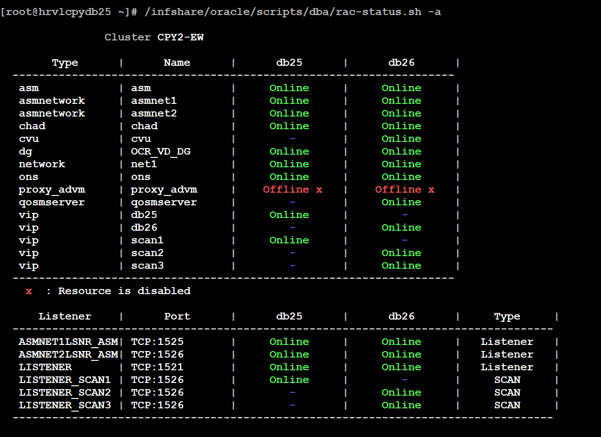



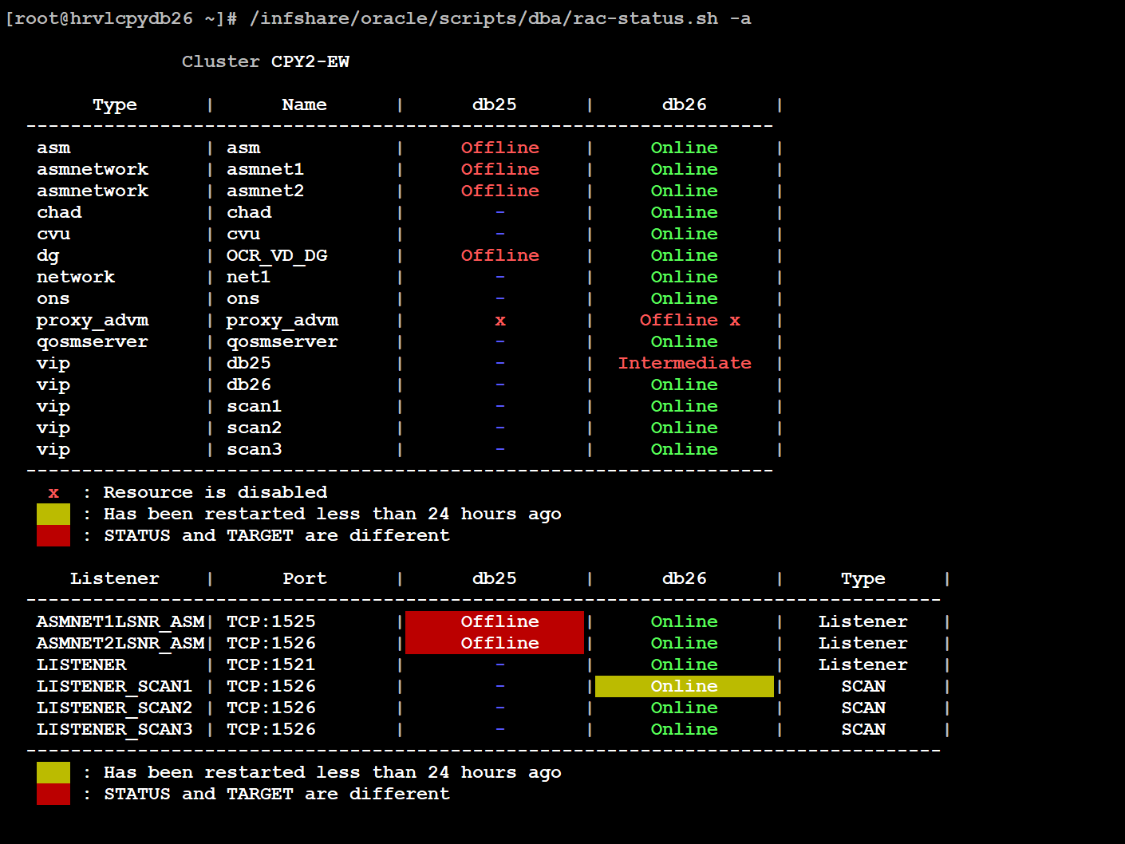

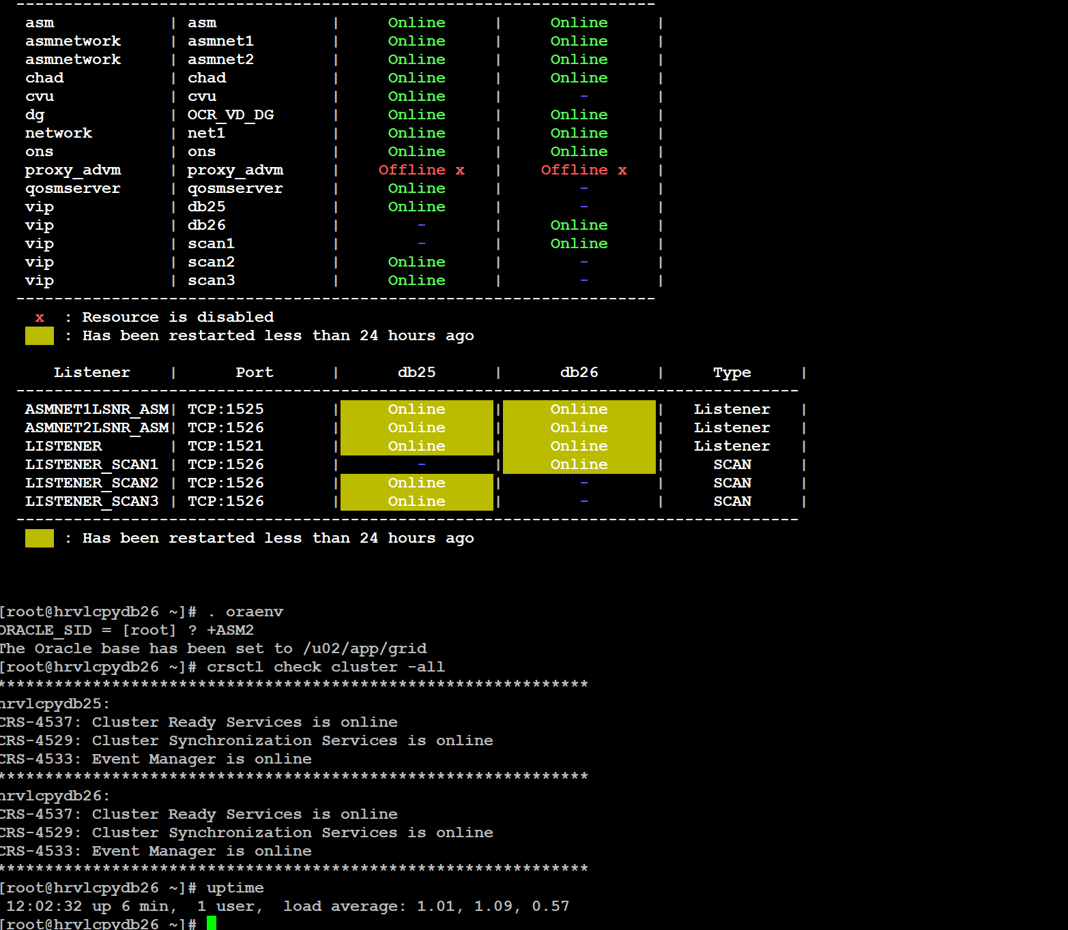

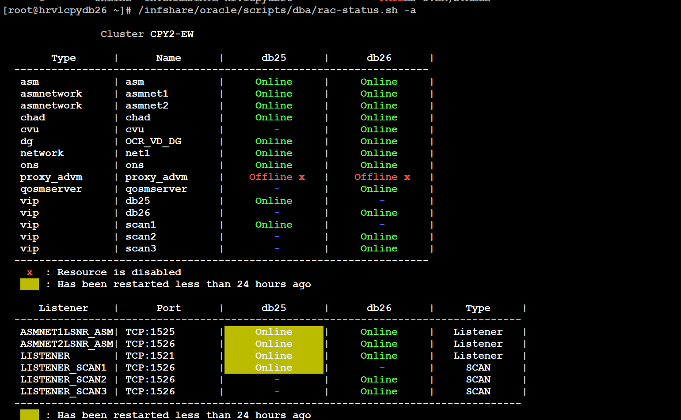

[root@hrvltstdb21 ~]# crsctl stat res -t

--------------------------------------------------------------------------------

Name Target State Server State details

--------------------------------------------------------------------------------

Local Resources

--------------------------------------------------------------------------------

ora.LISTENER.lsnr

ONLINE ONLINE hrvltstdb20 STABLE

ONLINE ONLINE hrvltstdb21 STABLE

ora.chad

ONLINE ONLINE hrvltstdb20 STABLE

ONLINE ONLINE hrvltstdb21 STABLE

ora.net1.network

ONLINE ONLINE hrvltstdb20 STABLE

ONLINE ONLINE hrvltstdb21 STABLE

ora.ons

ONLINE ONLINE hrvltstdb20 STABLE

ONLINE ONLINE hrvltstdb21 STABLE

ora.proxy_advm

OFFLINE OFFLINE hrvltstdb20 STABLE

OFFLINE OFFLINE hrvltstdb21 STABLE

--------------------------------------------------------------------------------

Cluster Resources

--------------------------------------------------------------------------------

ora.ASMNET1LSNR_ASM.lsnr(ora.asmgroup)

1 ONLINE ONLINE hrvltstdb20 STABLE

2 ONLINE ONLINE hrvltstdb21 STABLE

ora.ASMNET2LSNR_ASM.lsnr(ora.asmgroup)

1 ONLINE ONLINE hrvltstdb20 STABLE

2 ONLINE ONLINE hrvltstdb21 STABLE

ora.LISTENER_SCAN1.lsnr

1 ONLINE ONLINE hrvltstdb21 STABLE

ora.LISTENER_SCAN2.lsnr

1 ONLINE ONLINE hrvltstdb20 STABLE

ora.LISTENER_SCAN3.lsnr

1 ONLINE ONLINE hrvltstdb20 STABLE

ora.OCR_VD_DG.dg(ora.asmgroup)

1 ONLINE ONLINE hrvltstdb20 STABLE

2 ONLINE ONLINE hrvltstdb21 STABLE

ora.asm(ora.asmgroup)

1 ONLINE ONLINE hrvltstdb20 Started,STABLE

2 ONLINE ONLINE hrvltstdb21 Started,STABLE

ora.asmnet1.asmnetwork(ora.asmgroup)

1 ONLINE ONLINE hrvltstdb20 STABLE

2 ONLINE ONLINE hrvltstdb21 STABLE

ora.asmnet2.asmnetwork(ora.asmgroup)

1 ONLINE ONLINE hrvltstdb20 STABLE

2 ONLINE ONLINE hrvltstdb21 STABLE

ora.cvu

1 ONLINE ONLINE hrvltstdb20 STABLE

ora.hrvltstdb20.vip

1 ONLINE ONLINE hrvltstdb20 STABLE

ora.hrvltstdb21.vip

1 ONLINE ONLINE hrvltstdb21 STABLE

ora.qosmserver

1 ONLINE ONLINE hrvltstdb20 STABLE

ora.scan1.vip

1 ONLINE ONLINE hrvltstdb21 STABLE

ora.scan2.vip

1 ONLINE ONLINE hrvltstdb20 STABLE

ora.scan3.vip

1 ONLINE ONLINE hrvltstdb20 STABLE

--------------------------------------------------------------------------------

[root@hrvltstdb21 ~]#

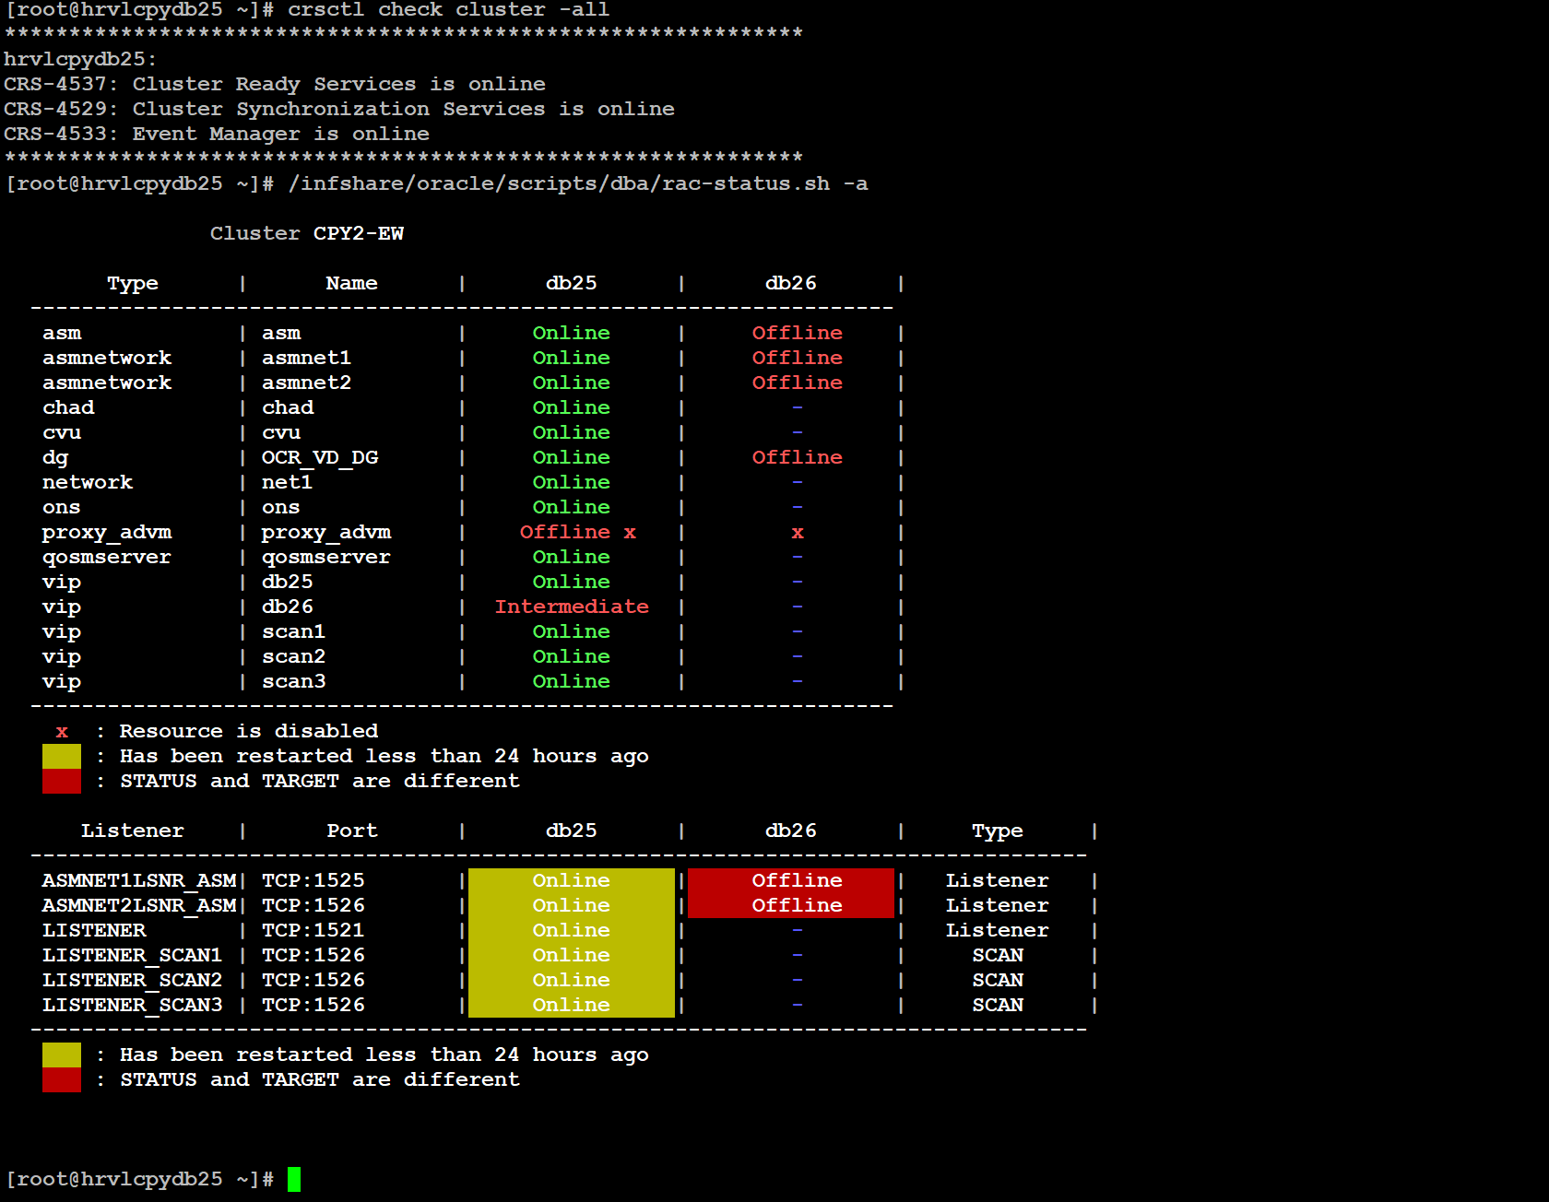

[root@hrvltstdb20 ~]# crsctl stat res -t

--------------------------------------------------------------------------------

Name Target State Server State details

--------------------------------------------------------------------------------

Local Resources

--------------------------------------------------------------------------------

ora.LISTENER.lsnr

ONLINE ONLINE hrvltstdb20 STABLE

ora.chad

ONLINE ONLINE hrvltstdb20 STABLE

ora.net1.network

ONLINE ONLINE hrvltstdb20 STABLE

ora.ons

ONLINE ONLINE hrvltstdb20 STABLE

ora.proxy_advm

OFFLINE OFFLINE hrvltstdb20 STABLE

--------------------------------------------------------------------------------

Cluster Resources

--------------------------------------------------------------------------------

ora.ASMNET1LSNR_ASM.lsnr(ora.asmgroup)

1 ONLINE ONLINE hrvltstdb20 STABLE

2 ONLINE OFFLINE STABLE

ora.ASMNET2LSNR_ASM.lsnr(ora.asmgroup)

1 ONLINE ONLINE hrvltstdb20 STABLE

2 ONLINE OFFLINE STABLE

ora.LISTENER_SCAN1.lsnr

1 ONLINE ONLINE hrvltstdb20 STABLE

ora.LISTENER_SCAN2.lsnr

1 ONLINE ONLINE hrvltstdb20 STABLE

ora.LISTENER_SCAN3.lsnr

1 ONLINE ONLINE hrvltstdb20 STABLE

ora.OCR_VD_DG.dg(ora.asmgroup)

1 ONLINE ONLINE hrvltstdb20 STABLE

2 ONLINE OFFLINE STABLE

ora.asm(ora.asmgroup)

1 ONLINE ONLINE hrvltstdb20 Started,STABLE

2 ONLINE OFFLINE STABLE

ora.asmnet1.asmnetwork(ora.asmgroup)

1 ONLINE ONLINE hrvltstdb20 STABLE

2 ONLINE OFFLINE STABLE

ora.asmnet2.asmnetwork(ora.asmgroup)

1 ONLINE ONLINE hrvltstdb20 STABLE

2 ONLINE OFFLINE STABLE

ora.cvu

1 ONLINE ONLINE hrvltstdb20 STABLE

ora.hrvltstdb20.vip

1 ONLINE ONLINE hrvltstdb20 STABLE

ora.hrvltstdb21.vip

1 ONLINE INTERMEDIATE hrvltstdb20 FAILED OVER,STABLE

ora.qosmserver

1 ONLINE ONLINE hrvltstdb20 STABLE

ora.scan1.vip

1 ONLINE ONLINE hrvltstdb20 STABLE

ora.scan2.vip

1 ONLINE ONLINE hrvltstdb20 STABLE

ora.scan3.vip

1 ONLINE ONLINE hrvltstdb20 STABLE

--------------------------------------------------------------------------------

[root@hrvltstdb20 ~]#

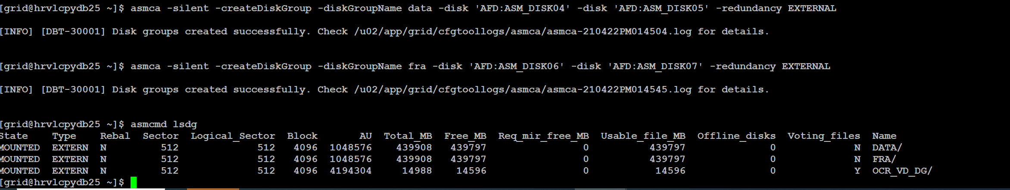

clea